Do I need to download the Survey123 app from an app store?
Yes. If you are using an Android phone or tablet, you can download the Survey123 app from the Google Play Store. If you are using an Apple device, you can download Survey123 from the Apple App Store. If you are using a PC laptop or desktop, you can download Survey123 from the Microsoft store.

Apple App Store Google Play Store Microsoft Online Store

Do I need an ArcGIS account to submit surveys?
No, you do not need an account to submit surveys or download the app. Simply click “Continue without signing in” when you open the Survey123 app to submit anonymously.

What are each of these surveys within the app?
Each of these surveys are specifically curated to help our core partners and
participating members collect citizen science data in the Lake Tahoe Basin. Some of the
surveys are seasonal and become more or less of a priority in winter and summer months while others are important to collect data from year-round. Below is information about each of our current surveys:
- Eyes on the Lake: Have you spotted aquatic invasive weeds? Report your sightings of these aquatic invaders to help prevent Tahoe’s blue waters from turning a murky green. Learn more about this program at https://www.keeptahoeblue.org/eyes.
- Algae Watch: Do you see any algae? Understanding the location and timing of algae growth can help us better control it. Learn more at https://tahoe.ucdavis.edu/algae.
- That’s Not Natural: Do you see litter, graffiti, or other human impacts where they should not be? Your reports will drive solutions for these “hot spots,” including community cleanup events.
- Water Quality: How does the water look? When the water is not clear, it can point to localized erosion or other problems that may require more investigation.
- Project Ashfall: Track wildfire ash and help scientists demystify fire-weather. This will help scientists who specialize in fire-generated weather to improve our ability to track fire using radar.
- Stories in the Snow: Share your snow crystal images.

Can I access surveys offline?
Yes. Once the surveys are downloaded to Survey123, they will be available offline. There are many places around the basin where we hope citizen scientists will collect data, but we know the cell signal may not be great. Fill out all the information you can, then add a location and submit your survey once you return to service.

How do I upload surveys that I completed while offline?
Surveys you complete offline can be saved to drafts to be submitted once you return to service. When you have filled in all the information you can, click the “X” button in the top left corner and then click ‘Save to drafts’ (below, left). Once you have returned to an area with cell service or Wi-Fi signal, your survey will appear in your drafts (below, right), where it can be accessed and submitted.
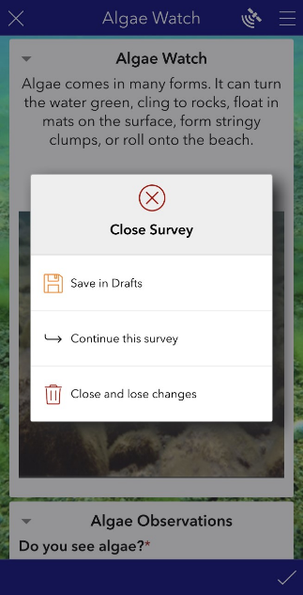

Why is the app asking me for my location?
Citizen Science Tahoe/Survey123 relies on the geolocation of a citizen scientist for
each survey to be able to follow up on observations made. For example, if a litter hotspot is reported, it is important for our team to know where that location is so it can be addressed by a cleanup crew. If you do not allow the app to access your geolocation, you will not be able to upload reports. This geolocation data is only collected at the time you start a new survey and should be verified to be correct prior to uploading survey reports.
How do I upload photos in the app?
- Option 1: Take a photo directly in the app with your smartphone using the camera icon. This is the easiest method.
- Option 2: Select the file folder icon to open your photos. You will first be asked which photos you are giving Survey123 access to. After this step, you will need to select the file icon again and choose a photo you would like the app to have access to. This image will now upload and be visible in the app.

How do I know I am accurately categorizing what I see?
There are expandable pictures next to each option in the survey. Select a picture for a more detailed look at the options.

Am I actually contributing to scientific discovery at Lake Tahoe?
Absolutely! The data you collect is extremely valuable to researchers who use it to monitor lake conditions. We appreciate your participation in the continued effort to study and care for Lake Tahoe!

