**Earth & Space Science Expo**

**Investigation Handbook**

Activity Resources for Volunteers and Elementary School Teachers

The “Earth & Space Science Expo Investigation Handbook” was created to assist volunteers with presenting science activities to the third-, fourth-, and fifth-grade students attending the annual Science Expo presented by the UC Davis Tahoe Environmental Research Center. The Science Expo is held annually each March and rotates between Earth & space science, life science and physical science thematic activities. Teachers scheduled to participate at this year’s annual Science Expo event may benefit by learning more about the science presented at the Science Expo for follow-up discussions and reflection with their students.

The design and format of the handbook is as follows: Each page details a specific science investigation. Investigations are divided into three categories: Geology & Earth Science, Weather & Climate, and Space Science. Each investigation uniquely considers various aspects of Earth or space science including weather, air pressure, cloud formation, stream-modeling, groundwater modeling, geology, fossils, space science, and more. Activity descriptions include the learning objective or “Passport Question, “Materials List,” “Procedure,” and “Talking Points.”

This handbook is designed to meet the intellectual needs of students enrolled in grades three through five as well as particular curricular standards that are determined and designated by Nevada and California departments of education. Procedures outlined in the “Earth and Space Science Expo Investigation Handbook” are for student use.

*For other questions or comments, please contact Heather Segale, UC Davis Tahoe Environmental Research Center education and outreach director at* [*hmsegale@ucdavis.edu*](mailto:hmsegale@ucdavis.edu) *or 775-881-7562.*

[Page blank intentionally]

**Geology & Earth Science**

**Just Around the Riverbend**

**Brief Description:** Students observe landforms taking shape as water flows through a streambed model.

**Passport Question:** Name three landforms created by water flowing over earth’s surface.

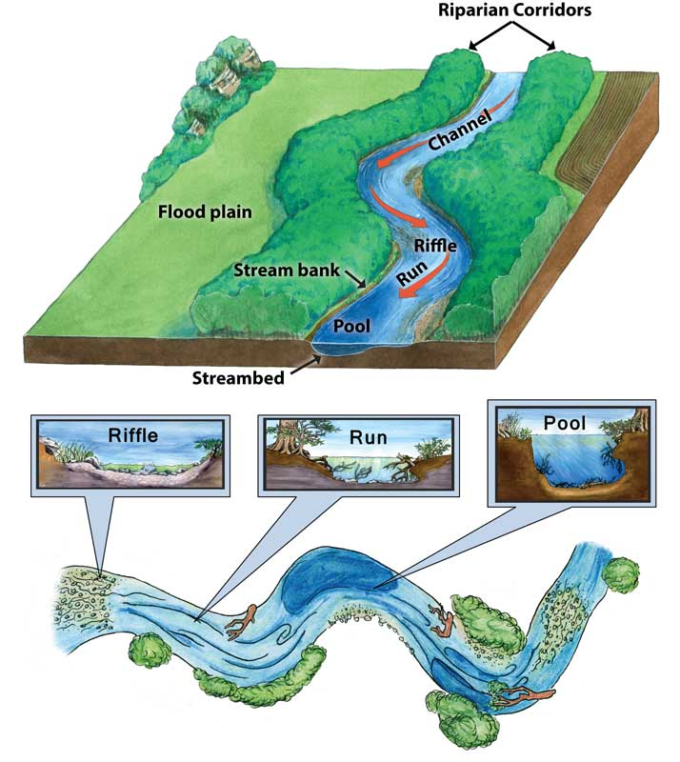**Passport Answer:** Answers will vary. Potential responses: alluvial fan, canyon, channel, delta, drainage basin, fjord, gorge, etc.

**Materials:**

* Streambed Table Model (with variable flow valve) – EM river2
* Water
* Bucket

**Background:**

* By looking at a stream model we can better understand how streams and rivers shape the Earth’s landscape.
* Water naturally flows downhill, but never in a straight channel. Erosion occurs and sediment is carried downstream.
* A stream is a body of water with a current, confined within a bed and stream banks.
* Streams are important because they serve as conduits in the water cycle, instrument in groundwater recharge, and corridors for fish and wildlife migration.



**Parts of a Stream:**

* Confluence: The point at which two streams merge.
* Run: A somewhat smoothly flowing segment of the stream.
* Pool: A segment where the water is deeper and slower moving.
* Riffle: A segment where the flow is shallower and more turbulent.
* Stream bed: Bottom of a stream.
* Waterfall or cascade: The fall of water where the streams goes over a sudden drop.
* Mouth: The point at which the stream discharges, possibly via an estuary or delta, into a static body of water such as a lake or ocean.

**Landforms Vocabulary:**

* *Alluvial fan:* A fan-shaped landform deposited at the end of a steep canyon where the slope becomes flatter.
* *Canyon:* A V-shaped valley cut by a river or stream.
* *Channel:* The course a stream follows; the deepest part of a river, stream, or harbor.
* *Dam:* A construction or wall across a river that holds back the water flowing through the river, creating a reservoir or lake.
* *Delta:* A fan-shaped (triangular) deposit of earth materials at a mouth of a stream.
* *Deposition:* The process by which eroded earth materials settle out in another place.
* *Drainage basin:* A system of rivers and streams that drains an area like the Colorado Plateau.
* *Erosion:* The breakdown and removal of soil and rock by water, wind, or other forces.
* *Flash flood:* A flood that rises and falls rapidly with little or no advance warning, usually as the result of very heavy rainfall over a relatively small area. Flash floods can be caused by sudden heavy rainfall, dam failure, or the thaw of an ice jam.
* *Flood:* A very heavy flow of water, which is greater than the normal flow of water and goes over the stream’s normal channel.
* *Floodplain:* Land that is covered by water during a flood, formed from sediments deposited by a river.
* *Landform:* A shape or feature of the Earth’s surface, like a delta or canyon.
* *Levee:* A natural or artificial wall of earth material along a river or sea that keeps the land from being flooded. Artificial levees are built to control flooding.
* *Meander:* A curve or loop in a river.
* *Plateau:* A large, nearly level area that has been lifted above the surrounding area.
* *Sediment:* Tiny bits of rock, shell, dead plants, or other materials transported and deposited by wind, rain, or ice.

|  |  |
| --- | --- |
| **Procedure** | |
|  | *Streambed model should be set-up on arrival.* |
| **1** | Have students (with their hands behinds their backs or off the model) predict what shape the water is going to make in the land form. |
| **2** | Turn the valve to release the water. Have students observe the formation and flow of a stream/river. |
| **3** | Ask the students what they think will happen if the volume of water flow changes. |
| **4** | Identify the streambed channel, an alluvial fan, erosion, V-shaped valley, and meander, or ask them if they can point out the landform. |

**Discussion:**

* Ask the students: *Where is erosion occurring? How would an increase in foliage (vegetation) affect the flow and shape of the stream? What’s the difference in the size of the sediment pieces left in the streambed and those that have run off?* 
  + Most erosion occurs on the outside edge of a bend in a river.
  + Increasing foliage will slow the water flow
* Ask the students: *Have you seen examples of this in real life? Where? How might erosion affect Lake Tahoe?*
  + When sediments erode and are carried into Lake Tahoe they can impact the Lake’s clarity.

**Modeling Convection Currents, Quakes, and Plates**

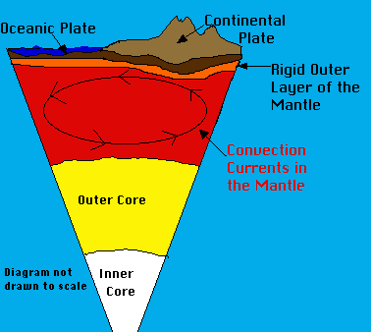**Brief Description: Part 1:** Students are given a demonstration on mantle convection currents. **Part 2:** Then, using sandpaper and rubber banded blocks, students learn how these mantle convection currents are the source of earthquakes, as currents drive the build-up and release of tension in tectonic plates.

**Passport Question:** What happens when stress and tension build up along a fault line?

**Passport Answer:** Earthquakes

**Materials:**

**Part 1**

* Glycerin
* Glitter
* Beaker
* Hot plate
* Crushed Ice
* Foam Continents

**Part 2**

* Wooden sandpaper blocks with rubber bands
* Styrofoam Fault Model
* Cardboard Plate Model
* Foam fault model

**Background:**

* The **upper mantle** is made of a much denser, thicker material than the mantle underneath and because of this the plates “float” on it like oil floats on water. Geologists believe that the mantle “flows” because of the convection currents.
* **Convection currents** are caused by the very hot material at the deepest part of the mantle rising to the upper mantle, then cooling. The cool material sinks back into the deep mantle where it is once again heated and rises, repeating the cycle over and over. When the convection currents flow in the mantle, they also move the crust and the tectonic plates on it. A conveyor belt in a factory moves boxes like the convection currents in the mantle moves the plates of the earth.
* Types of tectonic plate boundaries:

o  **Convergent**: Two plates are moving towards each other. Crust is destroyed as one plate dives under another. At continental-continental boundaries, mountains are formed from the uplift of continental crust. At oceanic-continental boundaries, the oceanic plate goes under the continental plate. At oceanic-oceanic boundaries, one of the oceanic plates dives under the other.

o  **Divergent**: This plate boundary occurs along spreading centers where plates are moving apart and new crust is created by magma pushing up from the mantle.

* + **Transform (Strike-Slip)**: A plate boundary where two plates are sliding past one another.

|  |  |
| --- | --- |
| **Part 1 Procedure: Demonstration of Convection Currents** | |
| **Set-up** | This demo will show convection currents within the mantle. The beaker and hot plate will be going upon arrival. The beaker is filled with glycerin and glitter. For the volunteer to add will be crushed ice to help encourage the current and two foam “tectonic plates”. These convection currents are responsible for the movement of plates and ultimately builds up stress and tension between plates. |
| **1** | Tell students this demo illustrates why stress and tension happens. The glycerin represents the mantle, the hot plate is the core, and the glitter helps show the movement of the convection currents. The glycerin should already be hot, so students can maybe already see some glitter movement. |
| **2** | Add crushed ice on top will help the glitter move back down the beaker so that the current can be observed. |
| **3** | Have students observe the movement of the foam “plates” on the surface. Ask if they know why the plates are moving on the surface of the glycerin. Discuss how this model is like the convection currents happening within the mantle. |

**Part 1 Discussion:**

* *Where does the heat that creates the convection currents come from?*

O The core.

* *How does the plate movement create earthquakes?*

O Link back to building up tension that eventually releases as an earthquake. The convection currents move plate tectonics around, and as the plates move past each other, stress and tension builds up.

* *Discuss what could happen if the convection currents were to stop.*

O If the currents stopped, then we could assume the outer core would solidify, causing the plates to stop moving and Earth’s climate to change. The Earth would either become extremely cold or hot, and it would be harder for life to exist on Earth.

* *How does density come into play with the magma in the convection currents?*

O Hot air rises when you heat it because it expands. When air expands, it becomes less dense than the air around it; the less dense hot air floats in the more dense cold air much like wood floats on water because wood is less dense than water. Similarly, the hotter magma will rise because it has expanded and is less dense, while the cooler magma will sink because it is more dense.

**Part 2: Quakes and Plates**

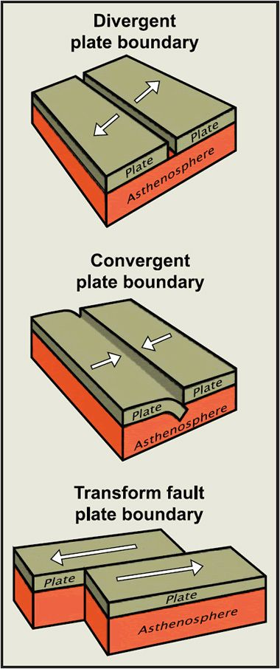**Part 2 Background for Volunteer:**

* Types of tectonic plate boundaries:

o  **Convergent**: Two plates are moving towards each other. Crust is destroyed as one plate dives under another. At continental-continental boundaries, mountains are formed from the uplift of continental crust. At oceanic-continental boundaries, the oceanic plate goes under the continental plate. At oceanic-oceanic boundaries, one of the oceanic plates dives under the other.

o  **Divergent**: This plate boundary occurs along spreading centers where plates are moving apart and new crust is created by magma pushing up from the mantle.

* + **Transform (Strike-Slip)**: A plate boundary where two plates are sliding past one another.
* Earthquake Vocabulary:

o  **Seismic Wave**: Two types that move through the earth’s crust and upper mantle

§ **Primary (P) waves** are compressional waves that are longitudinal in nature. They travel at about twice the speed of secondary waves (S waves) and can travel through both liquids and solids.

§ **Secondary (S) waves** are shear waves, so they are transverse in nature, meaning that they move perpendicular to the direction of energy transfer. They can only travel through solids.

o  **Seismograph**: An instrument that continuously measures the movement of the earth, including those generated by seismic waves.

o  **Elastic Rebound**: As rocks on either side of a fault shift in relation to each other, they build up energy until their internal strength is overcome and sudden fault movement occurs. This release of accumulated energy is called elastic rebound.

o  **Friction**: This is the force resisting the relative motion of solid surfaces.

* Pieces of the earth’s crust can break or fracture which releases energy. Crustal blocks can also “stick” and “slip” along a fault. When a large block “slips” it releases energy, causing an earthquake.
* Lake Tahoe was formed 2-3 million years ago when the Carson Range (East) and Sierra Nevada (West) blocks uplifted, and the blocks in-between down-dropped creating the Tahoe Basin.

|  |  |
| --- | --- |
| **Part 2 Procedure: Earthquakes and Plate Movement** | |
| **1** | Ask students if they know the names of any types of continental plate boundaries **(convergent, divergent, transform)**. Use the styrofoam model to explain the 3 different types of plate boundaries. Explain how Lake Tahoe was formed. Demonstrate using the cardboard model. The movement of the plates causes stress and tension, which can result in an **earthquake.** |
| **2** | Give each student a block and place block sandpaper-side down on the carpet. Have the student’s blocks side-by-side so they compete. |
| **3** | Have students slowly pull the rubber band (attached to the block) away from the block parallel to the carpet. The block should stick at first, but eventually slide. Have students compete to see how much tension can be created before the energy releases. |
| **4** | Explain to students how greater tension build up leads to a more uncontrolled release of energy. |
| **5** | After discussing how earthquakes are the release of built up stress and tension, bring students back to the convection currents model to remind that these currents and the buildup of stress and tension are constantly occurring. |

**Discussion:**

* *How does this model represent how an actual earthquake releases energy?*
  + Tension and stress build up until the blocks overcome friction. The blocks released energy when they slid. Earthquakes occur because of energy behind release in the crust.
* *How fast do you think tectonic plates move each year?*
  + Earth has between 10-20 crustal plates, each moving at different rates. The slowest (Eurasian Plate) moves less than an inch per year, while the fastest (Cocos Plate) grinds across the west coast of the Central America at approximately 8.55 inches per year.

o  Your nails grow approximately 1.5 inches per year.

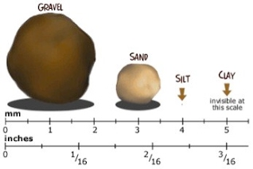**Shake and Break Down**

**Brief Description: (Part 1)** Students look at examples of different rock sizes and examples while learning about weathering and how this impacts rocks. **(Part 2)** Students then explore physical weathering by shaking a container of rocks to observe how they break down.

**Passport Question:** What are the two types of weathering? Chemical and ____.

**Passport Answer:** Physical

**Materials:**

* Part 1:
  + Large Shallow Plastic Containers of various sized granite pieces and sand
  + Sediment samples from various locations around Lake Tahoe
  + Hand Lenses
  + Microscope
* Part 2:
  + Plastic containers with large screw top lids (e.g., mayo jars, peanut butter jars, coffee jars)
  + Sediment to be shaken and broken apart
  + Multi-layer sieve
  + Baking tray
  + Towels

**Background:**

* **Weathering** is the breakdown of the earth’s rocks, soils, and minerals caused by the earth’s atmosphere. **Erosion** causes the same break down from the movement of rocks, soils, and minerals from forces like water, ice, wind, and gravity.
* There are two types of weathering: **Physical** and **Chemical**.

**Vocabulary:**

* *Physical (mechanical)*weathering causes changes through processes such as thermal stress, frost, or pressure which are not related to chemical changes. Wind, ice and water are also mechanisms for physical weathering because they transport materials that scour and weather other rocks. Rocks become smaller in size but are still made of the same material. Examples include wind, ice, gravity, water freezing in rocks, or plants growing in cracks of rocks.
* *Chemical*weathering changes the composition of rocks including dissolution from acid rain, hydrolysis of silicates and carbonates, and oxidation.
* *Erosion:* Moving of rock material by water, ice, wind, and even animals and humans.
* *Ice wedging:* when water between rocks freezes and forces them apart.

|  |  |
| --- | --- |
| **Part 1 Procedure: Observing Rocks to Understand Weathering** | |
| **Set-up** | Display rocks will be set out on the table when volunteers arrive. |
| **1** | Have students observe the big granite rock and the granitic sand. Ask them if the two look similar. Tell them the big rock does become the sand, but ask them how they think it does. Brainstorm different types of weathering and then go over the weathering and the two types. Let students observe the different types of rocks and sand with the hand lenses and microscope. |
| **2** | Use the hand lenses and microscope to encourage students to get a closer look and see that these two rocks are in fact the same though they are different sizes. |
| **3** | Discuss how, in nature, rocks change size, shape, and form. The following discussion questions can be discussed before and after part two of the activity. |

**Discussion:**

* *What causes physical/mechanical weathering?*

o  Ice wedging, pressure release, plant root growth, and abrasion.

* *What is an example of mechanical weathering occurring in real life?*

o  The Grand Canyon was formed by mechanical weathering (winds and the Colorado River) and erosion.

o  Soil can be created from weathered rock mixed with plant and animal remains

o  Trees’ roots can break large rocks.

o  Animals that tunnel underground also work to break apart rock and soil.

* *Why is the size of the sand important in Tahoe?*

o  Granite weathers into rather large sediments that would sink to the bottom of Lake Tahoe which helps keep the lake water clear.

o  Clarity has dropped in Lake Tahoe due to an increase in fine particles and sediments (from car exhaust and pollution). You could ask students where they think these come from and what they can do to prevent that.

* *What are some factors that may affect the rate of weathering?*

o  Humidity, rainfall, temperature, and sunlight all determine how fast or slow weathering will occur. Weathering also depends on the type of rock. For instance, limestone generally dissolves more easily in rainwater, because rainwater is becoming increasingly acidic from pollution.

**Part 2: Break Down**

|  |  |
| --- | --- |
| **Part 2 Procedure: Witnessing Physical Weathering Activity** | |
| **1** | In the Break Down, students learn about weathering. In this activity, they will see physical weathering happen before their eyes. Talk about physical weathering and examples of physical weathering. |
| **2** | Ask students to observe the rocks. *What do the rocks look like and how do the rocks feel?* Put a couple of rocks in a plastic jar and screw the lid tightly onto the jar. Ask students to make a hypothesis about what will happen to the rocks if they shake the jar, or why do they think they are shaking it. |
| **3** | Students then shake the rocks vigorously. They will only need to shake the container for 15-30 seconds to cause enough physical weathering. Feel free to turn on high-energy music! |
| **4** | Have the students pour the contents of their container into the top layer of the sieve. Then students will shake the sieve which will cause the sediments to separate based on their size. Separate the sieve into each layer to observe the outcome. Observe the rocks now. *What do the rocks feel like and look like?* |

**Discussion:**

* *What happened to the rocks as you continued to shake them?*

o  They got rounder, smaller, smoother, etc.

* *What do you think would happen if you shook the rocks for several hours or several days?*

o  The rocks would become very round and smooth. Eventually, the rocks would completely transform to sand.

* *Have students think about rocks they find at the ocean, are they usually jagged or round and smooth?*

o  Usually smooth, due to the wave action churning rocks over and over again.

* The rocks changed size and shape due to **abrasion** - the rocks rubbed against each other- breaking small pieces of the rock off. The small grains that break off feel like sand. Over time, the rocks become rounder and smoother.

**Rock Detective**

**Passport Question:** After completing your investigation, what is one type of rock that you discovered?

**Passport Answer:** Answers may vary but include: Calcite, Granite, Limestone, Pumice, Quartz, or Talc

**Materials:**

* Complete Rock Mineral Testing Kit (6)
* Magnifying Glasses (6)
* Safety Glasses

**Background:**

* 3 main types of rocks:
  + **Igneous** rocks like obsidian, pumice, granite and basalt are formed through the cooling and solidification of magma or lava.
  + **Sedimentary** rocks like lime stone, sand stone, and shale are formed by the **lithification** (compaction)of sediment layers under great *pressure*. Sedimentary rocks compose 5% of the volume of the earth’s crust.
  + **Metamorphic** rocks such as marble and quartzite have been changed from existing sedimentary rock types, limestone and sandstone respectively, and require *heat* and *pressure*.
* A **mineral** is a natural occurring solid with a unique and definite chemical composition.
* **Rocks** are aggregates of one or more minerals. Rocks and minerals can be identified by testing their hardness, luster, color, streak, cleavage, fracture, and specific gravity.
* Many rocks can look alike. Sometimes telling the difference between a limestone or marble and other rocks such as shale and quartzite can be difficult. Geologists use a variety of methods to determine the type, which students will experience in this experiment

1. **Mohs Scale Scratch Test** rates mineral hardness; diamond is the hardest mineral where talc is the least hard.
2. **Acid or “Fizz” test**. Rocks that contain calcium carbonate (limestone, oolitic limestone, coquina and marble) should “fizz”. The bubbles are telling you that your rock is a limestone or contains calcite like limestone.
3. **Float Test** gives an idea of the rock’s relative density
4. **Streak Tests** on ceramic plates give an idea as to the rock type based on the presence of a streak and the color

|  |  |
| --- | --- |
| **Procedure** | |
| **1.** | Tell them that today they are going to be rock detectives! |
| **2.** | Observe the different types of rocks on the table. *Are there any rocks you don’t know? How would you test the rock to find out what it is?* Talk about different types of tests used. |
| **3.** | Try to scratch each rock. Use your fingernail first, then the nail. Record what happened. Put an X on the chart if the rock was scratched. |
| **4.** | Put on gloves and put a very small drop of acid on each rock*. Was there a reaction?* Record what happened. Put an X on the chart if the rock reacted (bubbled). |
| **5.** | Drop the rock into the bowl of water. *Does it sink or float?* Put an X on the chart if the rock floated. |
| **6.** | Do a streak test on the ceramic plate. Run the rock lightly across the plate. *Did it leave a streak?* *What color was it?* Record your observations in the chart. |
| **7.** | Compare your chart to the Rock & Mineral Identification Key. *Which rocks are which?* |

**Discussion:**

* *Which was the hardest/ softest rock?*
* To determine if various rocks are composed of dolomite or calcite, you would need to conduct an acid test. *What happens in the acid test?*
* Using a magnifying glass, observe the characteristics of other minerals and rocks. *What do you see? Why is this information useful?*
* *Were you successful in determining your rock’s type?*

**Exploring Magnetic Field Lines**

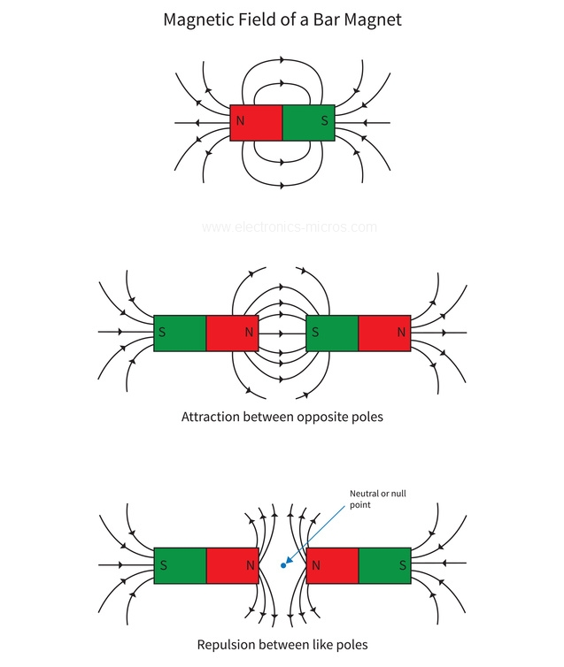**Passport Question:** Magnets have an invisible force field known as a ________________.

**Passport Answer:** Magnetic field

**Materials:**

* 2 sheets of 8.5” x 11” paper taped together lengthwise or 1 sheet of 17” x 11”
* Bar Magnet
* Compass
* Cow Magnet and Iron Filing Demo
* Cow Magnet and Magnaprobe Demo
* Magnetic Field Pattern Window Demo

**Background:**

* A typical magnetic compass is actually made with a tiny magnet that aligns itself with strong magnetic fields.
* Now imagine the Earth as a big bar magnet, with the poles at the North and South   
  Poles. The pointed needle tips of our compasses are attracted to the North Pole and help us find our way no matter where we are on Earth.
* Cow magnets have a pole at each end. Farmers place them in cows’ stomach to attract nails or small pieces of iron that the cow may ingest to prevent Hardware Disease.

|  |  |
| --- | --- |
| **Procedure** | |
| **1** | Ask students if they know anything about magnets (try to guide them to attraction and repulsion). Use the red and blue magnets to explain that, and then the magnaprobe to prove there are poles on the cow magnet. Ask students what it means when it flips form side to side. |
| **2** | Use the magnetic field pattern window to demonstrate a magnet’s magnetic field. Have students list some magnets that they know of; ask them what’s the biggest magnet they know (bigger than the moon?). |
| **3** | Tell students that you have a game for them. Ask students if they know what a compass is made of. Explain to them that a compass has a tiny magnet inside and that they will use a compass to trace out the magnetic field of a magnet. Divide up the magnets and compasses between the students. *Ask them what they think will happen if they put a compass next to a magnet, what will happen when they take the compass further away, and what will happen when they put it close to a different part of the magnet*. |
| **4** | Tape the bar magnet in the center of the two sheets of paper. |
| **5** | To make the tracing, have students do the following:   * Place the compass somewhere around, but not touching the magnet. * Draw a dot where the compass needle points away from the magnet. * Now move the center of the compass directly over the dot that was just drawn. * Draw a new dot where the compass needle points away from the magnet. * Continue to move the center of the compass over the recently drawn dot. * Draw a line to connect the draw dots to show how the magnetic field moves. * Repeat the steps above until the other end of the line meet the magnet or paper edge. * When finished with the first line, pick another spot near the magnet and repeat the process to trace more field lines. |

**Discussion:**

* *Have you used a compass before? Discuss your experience/ how it helped/ how you think it could be useful for others.*
* *Discuss how magnets are used in the “real world.”* 
  + In electrical motors, generators, and speakers
  + Sort magnetic and non-magnetic substances from scrap
  + In TV screens, computer screens, and telephones
  + Used in refrigerator to keep the door close
* *If you were standing on the North Pole, where would your compass point?* 
  + There are actually TWO North Poles- one at the top of the earth (North Pole) and one that is known as Magnetic North- and two south poles.
  + At the North Pole, if you hold the compass horizontally the needle which is supposed to point north will point south, toward the north magnetic pole (which is in northern Canada). If you were standing exactly on top of the magnetic north pole, your compass would point nowhere in particular since the place it is used to pointing to is at your feet.

**Discovering Fossils**

**Brief Activity Description: Part 1:** Students mimic paleontologists and dig through diatomaceous Earth to learn how fossils are formed and understand the "story" of sedimentary layers. **Part 2** Then students recreate the process of fossilization using bread, gummy candies, and lots of pressure.

**Passport Question:** What is evidence of past life preserved on Earth?

**Passport Answer:** Fossils

**Materials:**

* Diatomaceous Earth
* Fossil examples from diatomaceous Earth
* Fossil example images and models
* Paper towels
* 3 half slices of bread (one of white, wheat, and rye)
* Gummy candy fish (Swedish Fish)
* Magnifying lens
* Clear drinking straws
* 2 large wooden boards (one for a base, one for a top)

**Background:**

* Paleontologists are scientists who study fossils to understand ancient landscapes, climate, and life on Earth. **Paleontology** is the study of prehistoric times through the discovery and interpretation of fossils. Paleontologists search for and collect fossilized clues to piece together a picture of the environment and ecosystems of the distant past. As a historical science, paleontology incorporates mainly biology (the study of plants and animals) and geology (the study of rocks) to puzzle together facts to explain the past. In contrast, experimental scientists conduct experiments in order to disprove hypotheses.
* Fossils provide information about the environmental conditions that existed when the fossil organism was alive, as well as where, when, and how the organism lived.
* Fossils are formed by various ways. The dead organism can be preserved in amber (hardened tree resin), peat bogs, tar pits, or in ice. Casts or impressions (such as foot prints) could be covered by layers of sediments, which eventually become rocks preserving the casts.

|  |  |
| --- | --- |
| **Fossil Discovery Procedure** | |
| **1** | Students can touch the sediment in the large boxes of diatomaceous Earth. Show students the layers of this earth and where fossils could be found in these samples. |
| **2** | Show students some of the examples of fossils that have been found in this earth as well as some of the other fossil models that we have. Explain how sediments layer over time and show us geologic history. |
| **Fossil Formation Procedure** | |
| **1** | Place a piece of white bread (which represents the sandy ocean floor) on the paper towel. Put a gummy fish on the bread to represent dead marine life (say a whale from a million years ago). Place a piece of rye bread on the white (which represent sediment deposited by ocean currents), and a piece of wheat bread on top (which represents more sand and sediment deposited by wind and ocean currents over the millions of years). |
| **2** | Fold the paper towel to cover your bread fossil. Have students guess the two missing ingredients to make a fossil **(time and pressure)**. Place the bread between two wooden boards. Have students stand on it, to simulate the natural process of pressure over the millions of years. |
| **3** | Have students observe the bread fossil. Gently push the clear, glass straw straight down the bread and pull it back up to “extract” a core sample. Volunteer should use the straw so students don’t break the glass. Observe the layers through the straw. Ask them what the different layers or colors represent. |
| **4** | Have them try to separate the layers of the bread. *Ask them why they think the layers are difficult to separate.* Have them try to extract the fish. *Can they identify the fish fossil’s mold (impression in the bread)? How about the fossil’s cast, which is the mineral material that fills the hole left when the fossil is gone?* |

**Discussion:**

* *What can fossils tell us?*
* *How are fossils formed?*
* *What qualities should a paleontologist have to be successful at finding and excavating fossils?*
* *What did you enjoy about the process of “digging out” your fossils?*
* *What is another name for gasoline?* Fossil fuel.
* *How are fossil fuels formed?* Through pressure on decaying living organisms over long periods of time in geologic history.

**Volcano Loco**

**Brief Activity Description:** Students discover how magma composition and the structure of volcanoes affect magma flows by simulating various eruptions with paper cones over dry ice.

**Passport Question:** Which type of volcano erupts most violently?

**Passport Answer:** Composite Volcanoes

**Materials:**

* Dry Ice, Scotch tape, warm water, scissors, small beaker or cups, globes, brown construction paper, supplemental images, water, honey, pipettes

**Background:**

***Earth’s Layers:***

* **Crust**: The crust is the outermost layer of the earth, comprising the continents and ocean basins. It has a variable thickness, anywhere from 35-70 km in the continents and 5-10 k in the ocean basins.
* **Mantle**: Just under the crust is the mantle. It is composed mainly of dense ferro-magnesium silicates (iron, magnesium, and silicon). It is about 2900 km thick and is separated into the upper and lower mantle. This is where most of the internal heat of the Earth is located. Large convective cells in the mantle circulate head heat and may drive plate tectonic processes.
* **Inner and Outer Core**: There are two very distinct parts of the core; the outer and inner core. The outer core is 2300 km thick and the inner core is 1200 km thick. The outer core is composed mainly of nickel-iron alloy, while the inner core is almost entirely composed of iron. The outer core contains as much as 10% lighter elements than iron alloy. The inner core is thought to rotate at a different speed than the rest of the Earth and which contributes to the presence of the Earth’s magnetic field.

***Volcano Formation:*** Sometimes high temperatures and pressure cause the mantle to melt and become *magma*. When a large quantity of magma forms, it moves up to the surface through the crust, and then releases pent-up gas and pressure that makes the volcano erupt. Once magma escapes to the Earth’s surface, air or water turns the magma into *lava*.

***Magma Types:*** There are many different types of magma. They produce different types of lava ranging from fluid, fast moving basalt to slower, thicker, vicous lava. Since rocks are made of different materials that melt at different temperatures, the type of rock that is melted in the mantle will affect the magma that results, and therefore the lava that erupts from volcanoes.

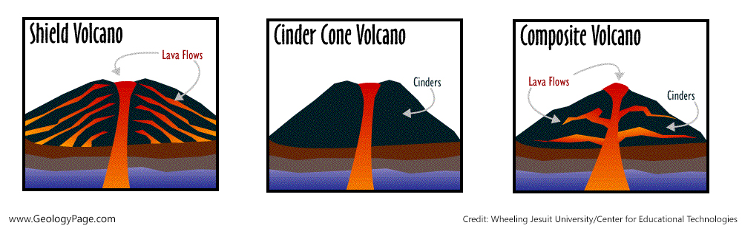

***Types of Volcanoes:***

* **Composite Cone Volcanoes** (Strato volcanoes) have some of the most explosive eruptions. The volcano is built of andesite or rhyolite lava, cinders and ash, and the overall size of the volcano tends to increase after an eruption. Strato volcanoes have very steep sides as a result of the viscous lava that builds up high pressures and stacks high on top of itself.
* **Cinder Cone Volcanoes** are named so because they were formed by lava fragments called cinders. This type of volcano only has one vent in which the magma can flow, unlike the composite and shield volcanoes. Since there is only one vent from which the magma can escape, the lava fragments burst into the air and then fall around the vent of the volcano. These volcanoes also have steep sides, but they are typically smaller than composite or shield volcanoes.
* **Shield Cone Volcanoes** got their name because they look like shields due to their gentle sloping sides. These gentle slopes are a result of the thin, runny lava that erupts out and spills over large distances. As the lava erupts more readily without massive pressure build-up, their eruptions usually have enough time for animals and people to move to safety. Shield Volcanoes can be some of the largest volcanoes in the world.

*Vocabulary:*

* **Ash**: Fragments of volcanic rock that explode from the vent of a volcano in solid or molten form.
* **Eruption**: The process that ejects solid, liquid, and gaseous materials onto the Earth’s surface and into the atmosphere by volcanic activity. These eruptions can range from violent explosions to quiet overflow of magma.
* **Lava**: Magma that is exposed to air or water on the Earth’s surface.
* **Magma**: Hot, molten rock that forms beneath the Earth’s surface.
* **Magma Chamber**: The chamber where the rising magma is collected before a volcano erupts.
* **Vent**: An opening from which volcanic material is released.

|  |  |
| --- | --- |
| **Procedure** | |
| **1** | Ask students if they know how a volcano erupts. Talk about the layers of the earth and how high temperature and pressure pushes the magma up as it is a lower density (similar to air pressure if they’ve done those activities). Now tell students to find two differences in the three volcanoes (the difference in slope and size of the opening). They can build their own volcanoes to see how different volcanoes erupt differently. |
| **2** | Using paper, scissors, and tape make cones of varying size to model conic and shield volcanoes. Use images as examples. Use laminated volcanoes as examples or for quick use. Optional: while students make their volcanoes, illustrate how lava of 2 different viscosities erupts by using water and honey in 2 different pipettes onto a plate. |
| **3** | Prediction: How do you think the shape of the volcano is related to the type of eruptions that formed it? Which volcano will produce the more explosive eruption, and how will its shape contribute to that? |
| **4** | Place the paper cones over the beaker with dry ice and warm water to observe the “lava” behavior and compare to your predictions. |

**Discussion:**

* Observations: *What do you observe about the eruption? Why do you think they look different based on the shape of the volcano?*
* *Which volcano do you think had the most explosive eruption and why?*
  + Composite Cone Volcanoes are steep sided and have some of the most explosive eruptions.

**Shaky Sediments**

**Passport Question:** Liquefaction is when wet ground temporarily loses strength and acts like a liquid during an earthquake. (Circle one)

**Passport Answer:** True

**Materials:**

* Large plastic tub
* Several pounds of fine-grained sand
* Water
* Large spoon/spatula
* Extra sediment
* Ping-pong balls
* Brick/weight to represent a building
* Rubber mallet

**Background:**

* Soil **liquefaction** occurs when a saturated or partially saturated soil substantially loses strength and stiffness in response to an applied stress such as shaking during an **earthquake** or other sudden change in stress condition, in which material that is ordinarily a solid behaves like a liquid.
* Sands feel solid because grains touch and support each other. Between the sand grains are pores—empty spaces that make up to 50 percent of the volume of the sand. Porosity or **pore space** refers to the volume of soil voids that can be filled by water and/or air. Often, these spaces are filled with water, called groundwater.
* Soil liquefaction is most often observed in saturated, loose (low [density](https://en.wikipedia.org/wiki/Density) or uncompacted), sandy soils. This is because a loose [sand](https://en.wikipedia.org/wiki/Sand) has a tendency to [compress](https://en.wikipedia.org/wiki/Compressibility) when a [load](https://en.wikipedia.org/wiki/Force) is applied.
* When loose or unconsolidated sediments are shaken, they try to settle into new positions. However, when seismic waves from an earthquake hit an area, the sand and water are rapidly compressed. This can cause the water pressure in the ground to go up significantly. Ground failure happens when this high-pressure water causes a reduction of friction between sand grains. When grain-to-grain contact is lost, sediments can flow like liquid. This phenomenon is called **liquefaction.**
* **Seismic waves** occur during an earthquake in the Earth’s crust and upper mantle. The shaking caused by these waves can lead to liquefaction.
* In the case of the weight “building”, liquefaction causes uneven support of the base, so it topples over. As for the ping-pong ball “storage tank,” its density is less than that of the surrounding sediments. It’s held underground by the weight of the solid sediments above—until an earthquake takes place. If the sediment undergoes liquefaction, the buoyancy of the ping-pong ball causes it to float up and through the temporarily liquid sediment.

|  |  |
| --- | --- |
| **Procedure: Demonstrating liquefaction as a result of an earthquake** | |
| **Set-up** | 1. Pour sand and water together into your basin. There should be enough sand to make a layer several centimeters thick, and just enough water to soak through the sand. Mix thoroughly and adjust your mixture so that all your sand is damp with no visible puddles. 2. On one side of the pan, use your spoon to scoop out a hole in the damp sand. Then place the ping-pong ball inside the hole. This will represent an underground storage tank. 3. Cover the ping-pong ball (but not too deep), flattening and smoothing out the damp sand to make sure the ball is not visible. 4. On the other side of the pan, wiggle the skinny end of the weight into the sand so it stands up like a building would. |
| **1** | Begin by asking students to tell you if they know of anything that happens during earthquakes. Some may respond with buildings falling down. If not, tell them that this is something that can happen when earthquakes happen. Ask them to predict why this might happen. |
| **2** | The container and sediment should be prepared before the volunteer arrives, but will need to be reset after each demonstration. The demo can be reset by using the spoon to “fluff” the sediment. This will unconsolidate the soil. There is a weight representative of a building as well as a ping-pong ball buried in the sediment to demonstrate how man-made objects such as pipes and water tanks can be unearthed when liquefaction occurs. It’s a fun surprise for students to not know the ping pong ball is buried, so try to reset the ball discreetly. |
| **3** | Gently and repeatedly tap the side of the bin with the mallet. Ask students to observe what happens to the sand, the brick, and anything else that may appear in the bin (the ping pong ball). The tapping causes the grains of sand to try to resettle and increases the water pressure in the pore space between the grains of sand. This results in the sediment appearing and acting as a liquid. The “building” may topple over or sink into the sediment. |
| **4** | “Fluff” the sediment to reset the demonstration. Rebury the ping pong ball. Show the students the demonstration multiple times as you talk through what is happening with the sediments. |

**Discussion:**

* Observations: *What do you observe happen during the earthquake?*
  + *How did the surface of sand change?*
  + *Did your building topple over?*
  + *Did anything emerge out of the sand?*
* *If you had to build in this sort of wet sand, what would you do to keep your building up?*

**Weather and Climate**

**Air is Everywhere**

**Passport Question:** Air moves from areas of           pressure to areas of          pressure.

**Passport Answer:** High to Low

**Background Information:**

When air is heated up it expands and when air is cooled it contracts. For example, on a really cold day your car’s tires may look flat because the air is cold and has contracted and is exerting less pressure on its container, the tire. If air is not in a container the change in pressure from temperature change can go unnoticed. It’s often only when we confine air to a container that we can detect this change in pressure. This experiment will let us see this change in pressure from cause by a change in temperature.

**Materials:**

* Glass pan
* Erlenmeyer flask
* Water, with food coloring
* Tea candles
* Lighter

|  |  |
| --- | --- |
| **Procedure** | |
| **1** | Pour the water into the pan and place the candle in the middle of the water. |
| **2** | Add 2 or 3 drops of food coloring to the water. This will make the movement of the water easier to see. |
| **3** | Ask the students what they think will happen when you place the flask over the candle. |
| **4** | Light the candle. |
| **5** | Cover the candle gently with the Erlenmeyer flask. If you force the flask down it will not allow air to escape out the bottom. |
| **6** | Have the students think about what is taking place both inside and outside of the flask. What invisible thing is inside the flask? Air may be invisible to the eye but it still takes up space! |
| **7** | Have the students carefully observe what happens to the water around the flask. It's bubbling! What happens to the candle flame? |

**Discussion:**

* The candle flame heats the air in the flask, and this hot air expands creating a high pressure area inside the Erlenmeyer flask. Some of the expanding air escapes out from under the flask — you might see some bubbles; this is because the high pressure air is escaping out of the bottom.
* When the flame goes out, the air in the flask cools down and the cooler air contracts quickly creating an area of low pressure inside the flask. The cooling air inside of the flask creates a vacuum. This partial vacuum is created due to the low pressure inside the flask and the high pressure outside of the flask. We know what you're thinking; the vacuum is sucking the water into the flask right?  You have the right idea, but scientists try to avoid using the term "suck" when describing a vacuum. Instead, they explain it as gases exerting pressure from an area of high pressure to an area of low pressure. After the candle goes out and the air inside the flask cools down and contracts, it has created a low pressure area. The air outside the flask now has a higher pressure, and therefore puts pressure on the water, moving it into the low air pressure area inside the flask.
* A common misconception regarding this experiment is that the consumption of the oxygen inside of the bottle is also a factor in the water rising. While there is a possibility that there would be a small rise in the water from the flame burning up oxygen, it is extremely minor compared to the expansion and contraction of the gases within the bottle. The water level rises rapidly when the flame is extinguished, if oxygen consumption was the main favor the water would rise at a steady rate.

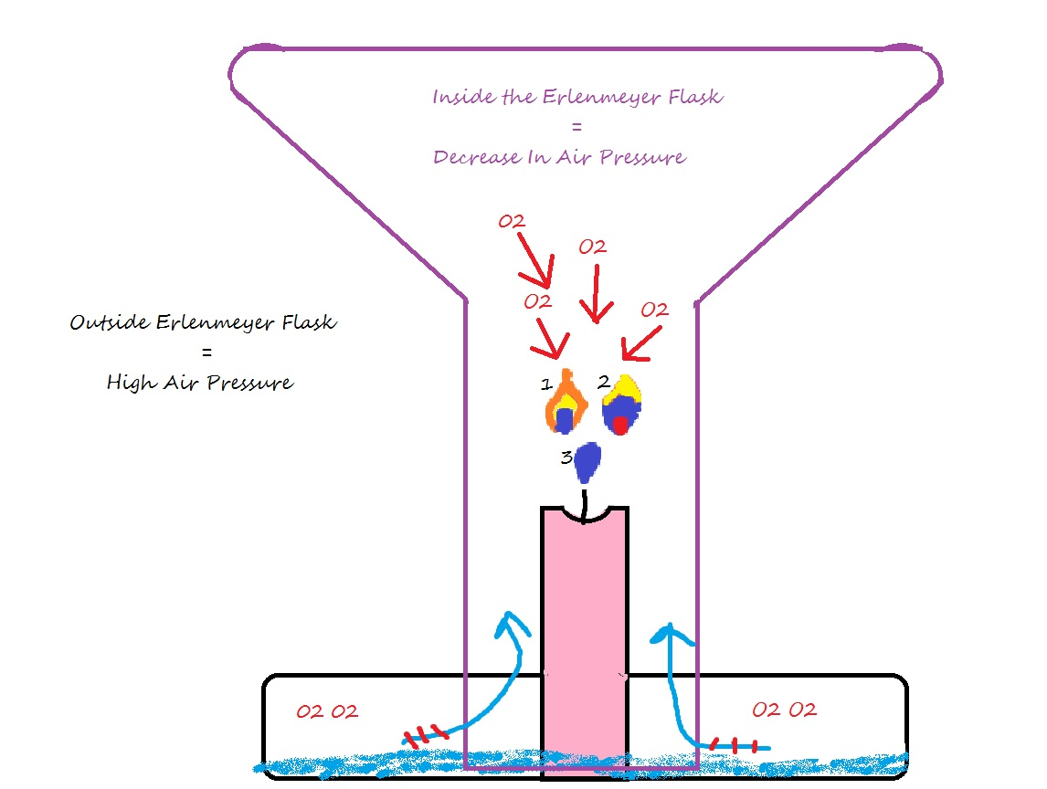

* Relate to weather: High pressure and low pressure system’s bring different types of weather. A low pressure system will bring cloudy and possible rainy conditions. A high pressure system brings sunny and clear conditions. They can learn more at the Kissing Balloons station.**Stubborn Balloon**

**Passport Question:** Does hot air or cold air take up more space?

**Passport Answer:** Hot Air

**Background information:**

**Air pressure** is the force exerted on you by the weight and motion of air molecules (tiny particles of air). Although air molecules are invisible, they still have weight and take up space. Since there's a lot of "empty" space between air molecules, air can be compressed to fit in a smaller volume. “Stubborn Balloon” displays the force associated with air pressure and its relationship with temperature and pressure.

**Materials:**

* Hurricane Vase
* Newspaper
* Lighter
* Water Balloon
* Water
* Straws
* Safety Goggles

|  |  |
| --- | --- |
| **Procedure** | |
| **1** | Put on safety goggles! |
| **2** | Place the water balloon on top of the jar and ask a student volunteer to try and push it into the jar. They will be able to push it in a little but it will always pop back out. (Make sure they don’t push too hard or the balloon will pop!) |
| **3** | Remove the balloon. **Be careful.** Wad up a piece of newspaper, light it on fire and drop it in the jar. When you are sure it is burning well, put the balloon back on the opening of the jar. The balloon may bounce up and down a couple times and will disappear into the jar. It may pop, that’s okay. I have supplied extra water balloons near the sink. |
| **4** | After the appropriate applause, ask the students if they want you to do it again (expect a yes!). Ask a student to attempt to pull the balloon back out of the jar. They won’t be able to do it. |
| **5** | After a sufficient number of tries hand them a straw. Ask them to hold the straw inside the jar, next to the edge, using their other hand pull out the balloon. The balloon should pop right out. |

**Discussion:**

* How does this work? It’s all about air pressure. The balloon wouldn’t go into the jar the first time because the air in the jar was pushing back up on the balloon as the student tried to cram it in. The air compresses slightly but not enough to allow the balloon to enter the jar.
* To understand how we got the balloon into the jar, we have to think about **equilibrium,** which is when opposing forces are in balance. Air molecules will move from areas of high pressure to areas of low pressure to maintain a balance of pressure, or equilibrium!
* When you place the burning paper into the jar, the fire begins to heat up the air inside, which makes it expand. The expanded air molecules try to find a way out of the jar, but the balloon resting on the top acts as a valve blocking the only exit. As the air continues to heat, the pressure builds inside the jar up until it is strong enough to lift the balloon (opening the valve) just enough to let out a “burp” of air from the inside. Once the jar burps, the pressure is reduced inside so that the balloon once again seals it off (the valve closed). The burping action can occur several times in rapid succession, which makes the balloon look like it is dancing a jog on top of the jar.
* Until now, the air pressure inside was higher than the pressure outside, evidenced by the fact that the air kept trying to get out. Remember though, two different actions are taking place inside the jar. The other action is that the fire is burning and consuming oxygen, which has the effect reducing air pressure. Eventually, the paper burns out when there is not enough oxygen to keep it lit. Then, the gases inside the jar begin to cool causing them to lose energy and slow down. This reduces the pressure inside the jar. Because the air pressure outside of the jar is greater than that inside the jar, the balloon is pushed into the jar by the outside air pressure.
* When we try to get the balloon back out of the jar, we again have the one-way valve problem. As the balloon is pulled to the bottom of the jar, the air inside is trapped behind the balloon. The minute this happens there is a balance of forces both inside and out. This balloon is not going to go anywhere when this happens. By inserting the straw you allow air to pass by the balloon. If the air can get into the jar, the forces never get a chance to balance and the balloon can be pulled from the jar very easily.
* Air pressure contributesgreatly to atmospheric stratification.In general as atmospheric height increases air pressure and density decrease. Temperature helps distinguish atmospheric layers:troposphere, stratosphere, mesosphere, thermosphere, and exosphere.

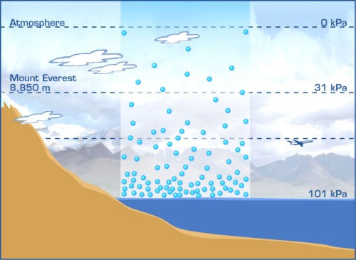

**Cartesian Divers**

**Passport Question:** True or False: Molecules of gas compress easier than molecules of liquid.

**Passport Answer:** True

**Background information:**

When you build a Cartesian diver, you are exploring three scientific properties of air:

(1) Air has weight

(2) Air occupies space

(3) Air exerts pressure (this is our focus)

Generally speaking, an object will float in a fluid if it’s less dense than the fluid. If the object is denser than the fluid, then the object will sink. For example, an empty bottle will float in a full bathtub because the air in the bottle is less dense than the water. However, as you start filling the bottle with water, its density increases and its buoyancy decreases. When it has enough water in it the bottle will sink.

The Cartesian diver, consisting of a plastic pipette and a metal hex nut, will float or sink in the bottle of water depending on the water level in the bulb of the pipette. When pressure is applied to the outside of the bottle, water is pushed up inside the diver, and the air inside the bulb is compressed into a smaller space. Molecules of gases are more easily compressed than molecules of liquids. The more water that is inside the diver, the denser it becomes and the diver sinks. When the pressure on the outside of the bottle is released, the compressed air inside the diver expands and this pushes some of the water back out of the diver. As the water level inside of the diver drops, the diver loses density and floats to the top.

The Cartesian diver activity represents the way a barometer works. When there is high pressure in the atmosphere the air inside the barometer will be exposed to the atmospheric high pressure as well as the water outside the Barometer. This will cause the air to push a bit harder on the water, causing it to rise. Similarly, with the Cartesian Divers, when we squeeze the bottle, we raise the air pressure which will raise the water level.

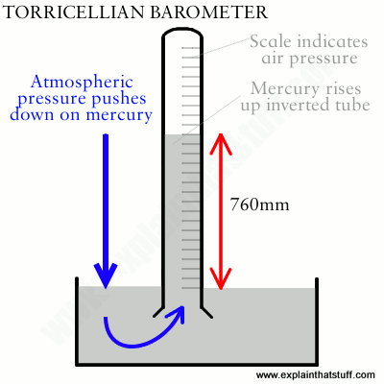

**Materials:**

* 1 or 1.5 liter bottles
* Plastic pipettes
* Hex nuts
* Hook and sinker
* Squidy

|  |  |
| --- | --- |
| **How to Make a Diver** | |
| **1** | To make a diver:   1. The standard Cartesian diver is made from a plastic pipette and a hex nut. Screw the hex nut onto the base of the pipette. Several turns of the hex nut should be sufficient to hold it in place. 2. Cut off all but 1/4 of an inch of the pipette stem. This is the standard diver. 3. Place the diver in a cup of water, making sure that the water in the cup is at least four inches deep. Notice that the diver floats. Why? While the diver is still in the water, squeeze the bulb of the pipette to force air out and release pressure to draw water up into the diver. Continue squeezing air out and drawing water up into the diver until the pipette is about half full of water. Let go of the diver and see if it still floats in the water. When properly adjusted, the diver should just barely float in the cup of water. If the diver sinks to the bottom, squeeze out a few drops of water and re-test. |
| **2** | **Divers will be all premade, but if one malfunctions try the above tactics to fix it**. |

|  |  |
| --- | --- |
| **Classic Cartesian** | |
| **1** | This bottle only has a hex nut and pipette Cartesian diver. |
| **2** | Squeeze the bottle and the diver will float down. |
| **3** | Fun trick! Magnetic finger: “Test” and see which student has a magnetic finger. Have the first student run their finger down the bottle to see if their finger is magnetic and will bring down the diver. Don’t squeeze the bottle on this one. Have a second student run their finger down the bottle, this time squeezing the bottle stealthily to sink the diver. That student’s finger is “magnetic”! After they are blown away with the trick explain them how you squeezed the bottle to make the diver sink. |

|  |  |
| --- | --- |
| **Squidy** | |
| **1** | This bottle has a squid covering a hex nut and pipette Cartesian Diver. |

|  |  |
| --- | --- |
| **Hook and Sinker** | |
| **1** | This bottle has two divers, one a hook and one a sinker. |
| **2** | The students can play with this, trying to squeeze the bottle enough to drop the hook and hook it onto the sinker. |

|  |  |
| --- | --- |
| **Counting Cartesian** | |
| **1** | This bottle has numbered Cartesian Divers 1-5, made with hex nut and pipette. |
| **2** | The five different divers contain different amounts of water, labeled 1 through 5. |
| **3** | When you squeeze the bottle, diver #1 will descend followed by diver #2 and so on. |
| **4** | You can have quite a bit of fun with this just in the way you present it to the students.  “Here is a bottle with five trained Cartesian Divers. What? You don’t believe me? I’ll show you. Watch as I command diver #1 to sink.”  Hold the bottle up and gently squeeze to make diver #1 sink to the bottom. Don’t let anyone know you are squeezing the bottle.  “Now, it’s #2’s turn.”  Secretly squeeze the bottle a little harder and make the second diver sink. Divers #3 through #5 are more difficult to sink because they have less water and may require the use of the special pump. Lift the top of the pump and push it back down. The pump forces a small amount of air into the bottle and this, in turn, increases the pressure on the air in the divers. By repeating the pumping action, it is very easy to make all of the divers sink. Loosen the cap just as you would when you open a bottle of soda and the divers will jump back up to the top. |
| **5** | Diver #1 contains the greatest amount of water because you adjusted the water level inside so that it would just barely float. Since diver #1 has the most water, it has the smallest pocket of air. When you squeeze the bottle, this diver will descend first. On the other end of the scale, diver #5 contains the least amount of water and has the largest pocket of air. Diver #5 is the most buoyant of the five divers and should be the last one to sink.  The divers will progressively sink in the order 1 to 5 if the densities of the divers are properly adjusted. You will also notice that you have to squeeze harder and harder to get each successive diver to sink. In essence, you have created a strength tester. One person may only be strong enough to sink three divers while someone else may have the strength to sink all five. How strong are you? |

**Discussion:**

* How Does It Work? The Cartesian diver, named after French philosopher and scientist René Descartes, works because of several factors.
* When you squeeze the sides of the bottle, you are increasing the pressure on the liquid inside. That increase in pressure is transmitted to every part of the liquid. That means you are also increasing pressure on the pipette itself.
* Squeeze hard enough and you will push some more water up inside the dropper. The air inside the pipette squeezes tighter as more water is forced in.
* Increasing the Density: Now, water is much denser than air. So when you push more water inside the pipette, you increase its overall density. Once its density is greater than that of its surroundings, it will sink.
* Release the pressure on the bottle’s sides and you stop forcing water inside the pipette. The air inside it will now push out the extra water again, and the pipette will rise. That’s the Cartesian Diver!

**Weather Glass**

* A weather glass is a small open barometer filled with water. It is a simple instrument designed to indicate atmospheric pressure rises and falls as the water in its spout falls or rises. It does not provide quantitative measurements of atmospheric pressure.
* The principle is that the air left in the bottle above the water exerts the pressure of the air at the time the bottle was filled, while the liquid in the spout is exposed to the changing atmospheric pressure. As the atmospheric pressure falls, the water in the spout rises, and vice versa. Because the spout is much narrower than the bottle, changes in water level in the bottle are amplified in the spout and so are easily visible.

**Galileo Thermometer**

* The weight of each tag is slightly different from the others.
* The bubbles are calibrated by adding a certain amount of fluid to them so that they have the exact same density
* The basic idea is that as the temperature of the air outside the thermometer changes, so does the temperature of the water surrounding the bubbles. As the temperature of the water changes, it either expands or contracts, thereby changing its density. So, at any given density, some of the bubbles will float and others will sink. The bubble that sinks the most indicates the approximate current temperature.

**Freak out! Is Tahoe weirding?**

**Passport Question:** According to the data, which date range experienced a higher frequency of severe weather and storm events?

**Passport Answer:** 2000-2019

**Background:**

Climate change is affecting the frequency and intensity of natural disasters across the world. These events can range from extreme flash flooding to long-term droughts. The climates where we live will expose us to different types of severe weather events. It is important for humans to record these different weather events in order to have a comprehensive understanding of how they are changing over time. We will see that in the last century, extreme weather events are more likely to occur and with a higher intensity. The data we record can help us determine how much our climate is changing over time.

**Supplies:**

Computers with internet access

Severe Weather Event Graph

White Boards

Datasheets

**Procedure:**

|  |  |
| --- | --- |
| **Procedure** | |
| **1** | Ask students to list some of the different types of extreme weather events that occur in Lake Tahoe. Allow students to raise their hands and let a couple of them share. You can explain that depending on where they live they might experience different weather events. You can also ask them if they know the difference between weather and climate? **Weather is what you experience when you walk out of the door. Climate is the average overall weather for a longer period of time.** |
| **2** | Tell students that today they will be researching the frequency of different extreme weather events that have occurred in Lake Tahoe in the last 40 years in order to determine if the climate has changed in that timeframe.  After we find how many times these weather events have occurred, we will create a graph to compare how the frequencies of each weather event have changed over time (1980-1999 to 2000-2019). |
| **3** | The computers/ipads will already be logged on to the National Climatic Data Center’s online Storm Data Archive at [https://www.ncdc.noaa.gov/stormevents/choosedates.jsp?statefips=6,CALIFORNIA](https://www.ncdc.noaa.gov/stormevents/choosedates.jsp?statefips=6%2CCALIFORNIA) |
| **4** | Help students locate the state they want to look up (California for Placer County or Nevada for Washoe County). |
| **5** | Remind the students that they are investigating the difference in weather and storm frequency for two different time periods to observe the change in the climate. They must look up each weather event for **both date ranges**. |
| **6** | Help the students change the begin date to January 1st, 1980 and the end date to December 31st, 1999. The second date range starts January 1st, 2000 and the end date is December 31st, 2019 |
| **7** | Help the students locate either Placer or Washoe County. |
| **8** | After the students enter the state, county, and dates have them look at the severe weather event tab and have them select Avalanche events. They should then be sent to the Data page and should look at the “Number of days with Event” row. |
| **9** | After locating the row have them record the number of days that avalanches have occurred on their datasheet under the correct date range. |
| **10** | Have students additionally search for drought, flood, hail, heavy snow, high wind, wildfire, and winter storm and record all of the events on the graph. Have them look up as many of these different weather events as they can in 5-10 minutes. They don’t need to get through all of the weather events as long as they have enough data recorded to make a graph. |
| **11** | Next have them graph their data on the whiteboard provided. You can ask them if they have learned about graphs before and what kind of graph they think best represents their data. You can help them create the axis because this can be confusing for some students. The two graphs that work best for this activity is a side by side bar graph or a scatter plot. See below for tips on graphing this data. |
| **12** | Once they have graphed everything have the students make observations about any patterns they see on the graph. It should paint a picture of how much more frequent severe weather events have become over time. |

**Tips for graphing the data:**

For a bar graph: The weather events go on the x-axis, and the number of days with the event goes on the y-axis. There should be two bars per weather event, one for each date range. These bars should be colored in two different colors to highlight any patterns between the date ranges. The other graph that works has the same set up but instead of bars it would be scatter points. After they have put two dots for each event they can connect the 1980-99 dots and the 2000-19 dots to create two lines. This is a good visual representation because the lines should never cross, the 2000-19 line will always be higher. **However, if they make this kind of graph you must point out that there is no connection between the weather events.** We are only connecting the line to highlight the pattern the graph shows.

**Discussion:**

*This activity is a good introduction into the world of data and research. It is very important for Scientists to keep records of past events in order to analyze and look for patterns. It also allows us to present information to the public in an easy and digestible way.*

*Do you think that the data you collected shows a pattern of climate change in Lake Tahoe?*

Yes, it does! The frequency of every severe weather event is higher in the 2000-2019 date range than the 1980-1999 range.

*Is this pattern a good or bad thing, or neither?*

*How does this graph give us insight into our climate?*

*Do you think that in twenty years from now the data will continue to show this pattern?*

**Updrafts in Action**

**Passport Question:** What two things together cause large hail to form?

**Passport Answer:** Very strong updrafts and super cooled water droplets.

**Background:**

Rain and hail will be suspended by the updraft (an upward current of air) inside a thunderstorm until the weight of the hail and water can no longer be supported. The stronger the updraft in a thunderstorm, the more intense the storm will be, and the larger the size of hail that can be produced. Suspending a ping pong ball in the stream of air supplied by a hair dryer will demonstrates how hail is supported in thunderstorm updrafts, and why with very strong thunderstorms we can see very large hail.

**Bournoulli Principle** - named after Daniel Bernoulli, an eighteenth-century Swiss scientist, who discovered that as the velocity of a fluid increases, its pressure decreases. The ping pong ball remains in the stream of air due to lower pressure created around the surface of the ball due to the Bournoulli Principle.

This low pressure effect also can be seen around the ping pong ball albeit in a different way. Instead of a narrowing in the center as in the venturi tube, the narrowing takes place around the perimeter of the ping pong ball (see figure right). In effect, there is an area of low pressure immediately adjacent to the ball.

**Supplies:**

Ping Pong Balls/Styrofoam Balls

Air Pump/Hair Dryer

Pictures of Hail

Different Styrofoam balls to show the sizes of hail

**Procedure:**

|  |  |
| --- | --- |
| **Procedure** | |
| **1** | Ask students if they know how hail is created? Allow some answers. Tell students that today they will be learning about updrafts and how pressure plays a role in the formation of hail. |
| **2** | To demonstrate how updrafts and pressure affect the formation of hail and rain we will be using an air blower and ping pong balls or Styrofoam balls. |
| **3** | Turn the air pump on and slowly insert one of the balls into the air stream. They should see the ball being held and oscillating in the air stream a bit. Ask them why they think the ball is moving around? ( Allow time for input) |
| **4** | Now tell them that we are going to put two balls in the air stream, and if we are lucky we might see them change position. |
| **5** | Attempt to put one ball in again, and then put another ball in the air stream. They should both be held and could possibly switch places in the stream. (Have some extra balls nearby in case they fall out of the stream and roll away.) |
| **7** | You can then attempt to use the other blowers. Some of them have very strong air streams. Attempt to hold the ball in a powerful airstream. The ball should be held at a higher elevation. You can then explain that at higher elevations the air is colder. Allowing larger hail to form. Again, the stronger the updraft, the larger the hail possible. |
| **6** | Once you have done the demonstration a couple times lead the students into a discussion about hail and updrafts. |

**Discussion:**

*Why do you think the ping pong ball moved from side to side in the air stream? (Explain to them that as the speed of air increases the pressure will decrease. The air sped up around the ball creating an area of low pressure just to the side of it.)*

*Hail is formed when* very strong thunderstorm **updrafts** meet super cooled **water droplets**. Super cooled **water droplets** are liquid water drops that are surrounded by air that is below **freezing**, and they're a common occurrence in thunderstorms.

(Ask students how they think extremely large hail is formed?)

Tell them that if the updrafts is strong enough it will suspend the hail in the air allowing more water to freeze around the other frozen water droplets until it is too heavy to be held by the updraft. Extremely strong updrafts can create very large hail!

They can then view the pictures of different hail and look at the different sized Styrofoam balls that represent the hail sizes.

**Cloud in a Bottle**

**Passport Question:** What causes clouds to form? Circle all that apply.

**Passport Answer:** Water Vapor, Air Pressure, and Condensation.

**Background Information:**

A **cloud** is a visible mass of liquid droplets made of water, suspended in the atmosphere above the earth’s surface. They are formed by two processes: cooling the air or adding water vapor to the air. Often these processes act together to form clouds.

There are several different types of clouds, classified by their shape, altitude (height in the atmosphere), and density. Latin roots are used to indicate the shape and density, with prefixes occasionally used to indicate altitude:

|  |  |  |  |  |
| --- | --- | --- | --- | --- |
| **Latin Root** |  | **Translation** |  | **Example** |
| cumulus  stratus cirrus nimbus |  | heap  layer curl of hair rain |  | fair weather cumulus  altostratus cirrus cumulonimbus |
|  |  |  |  |  |
|  |  |  |  |  |

Cumulus clouds are the big, fluffy type; stratus clouds appear in layered sheets; cirrus clouds take the form of thin wisps; and nimbus clouds are the thick, dark types that often produce precipitation. Have students think about what types of clouds they see during pleasant weather or during storm events.

**Materials:**

* 1-liter clear plastic bottle with cap
* Foot pump with rubber stopper attached
* Water
* Rubbing alcohol
* Temperature sticker and guide

|  |  |
| --- | --- |
| **Procedure** | |
| **1** | Ask the students what they know about clouds. *How are they formed?* *What are they made of?* Explain that water molecules are in the air all around us. These airborne water molecules are called water vapor. When the molecules are bouncing around in the atmosphere, they don't normally stick together. Clouds are formed when the water vapor cools and compresses into visible droplets. We’ll explain this a bit more after making a cloud of our own! |
| **2** | Place a few drops of rubbing alcohol in the bottom of the 1-liter bottle. We use rubbing alcohol instead of water because it volatilizes quickly and works better in this demo. You don’t have to tell the students you’re using rubbing alcohol. |
| **3** | Swirl the alcohol around in the bottle, making sure to coat the sides. Then put the rubber stopper in the bottle. |
| **4** | Have the students pump the foot pump 10 times while holding the stopper down to make sure it doesn’t pop off the top of the bottle. You can hold the rubber stopped down for them. |
| **5** | As they are increasing the pressure inside the bottle have the students look at the thermometer on the side (it looks like a skinny black sticker). You should be able to see the temperature change as the pressure does. Ask the students if they know why the temperature is changing (increasing the pressure increases the temperature). |
| **6** | When they are done pumping, pull out the stopper. You should see a cloud form in the bottle! |
| **7** | You can then pump air back into the bottle and watch the cloud disappear. |

**Discussion:**

* *Ask students why you were using the pumper.* Pumping the bottle forces the molecules to squeeze together or compress. Releasing the pressure allows the air to expand, and in doing so, the temperature of the air becomes cooler. This cooling process allows the molecules to stick together - or condense - more easily, forming tiny droplets. Clouds are nothing more than groups of tiny water droplets!
* The reason the rubbing alcohol forms a more visible cloud is because alcohol evaporates more quickly than water. Alcohol molecules have weaker bonds than water molecules, so they let go of each other more easily. Since there are more evaporated alcohol molecules in the bottle, there are also more molecules able to condense. This is why you can see an alcohol cloud more clearly than a water cloud.
* Clouds on Earth form when warm air rises and its pressure is reduced. The air expands and cools and clouds form as the temperature drops below the dew point. Invisible particles in the air in the form of pollution, smoke, or even tiny particles of dirt help form a nucleus on which the water molecules can attach.
* The temperature inside the bottle increases as you increase the pressure with the foot pump. This is due to the relationship between temperature and pressure (PV=nRT). As air warms up the molecules expand which increases the pressure on the container the air is in. As the temperature decreases, the air molecules condense and the pressure lowers.
* **Connection Chance –** When you pump air back into the bottle and watch the cloud disappear you are simulating what happens in the natural world. High pressure brings clear conditions while low pressure brings clouds.

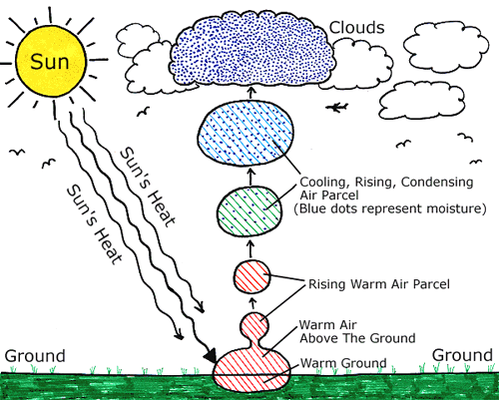

**Kissing Balloons**

**Passport Question:**  Blowing between the balloons creates a low pressure system which brings them together and results in what type of weather?

**Passport Answer:** stormy

**Background information:**

**Air pressure** is the force exerted on you by the weight of tiny particles of air. These air molecules are invisible, but, they still have weight and take up space. Changes in temperature affect how many molecules are packed into the atmosphere.

**Warm air = low-pressure systems:**Warm air expands so there are fewer air molecules in the atmosphere. Low pressure systems usually bring clouds and rainy days.

How low-pressure systems create clouds and rain:

In the Northern Hemisphere, a low-pressure system forces winds to spiral counterclockwise. Air is forced toward the center of this spiral and has nowhere to go but up. As the air rises, it cools (because the atmosphere gets colder as altitude increases). Cold air can’t hold as much water vapor as warm air, so the water condenses or comes together, to form clouds. When the water droplets join together and get too heavy, they may fall as rain or snow (which meteorologists call “precipitation”).

**Cool air= high-pressure systems:**

Cooler air contracts, which means air molecules become smaller and take up less space (so more of them can be packed into the atmosphere). High-pressure systems usually bring sunny days.

How high-pressure systems create clear skies:

In the Northern Hemisphere, high-pressure system winds spiral clockwise, moving from the center outward. To replace the air that flows out of the storm’s center, more air is sucked down from up higher in the atmosphere. This air warms up as it is pulled down. The warm air expands, and any clouds or precipitation that had formed disappear.

**Materials:**

* Balloons
* String
* Rod

|  |  |
| --- | --- |
| **Procedure** | |
| **1** | Tie the strings to the rod; make sure the balloons are at the same height. |
| **2** | Ask the student: What happens if you blow between the balloons? Where will they go? |
| **3** | Blow in between the balloons. Were your predictions correct? |

**Discussion:**

* Why do the balloons blow together instead of apart? In your experiment a low pressure area is created between the balloons when you blow in between them. The faster the air moves between the balloons, the lower the air pressure in that space.
* Meanwhile, the air surrounding the balloons now has higher pressure so it pushes the balloons together. This is an example of how low pressure systems cause air molecules to expand, and then condense into clouds.

Follow up: test students weather prediction skills! Print out weather isobar weather maps indicting H and L pressure systems.

1. Where is their potential for rain?
2. Where is it probably sunny?

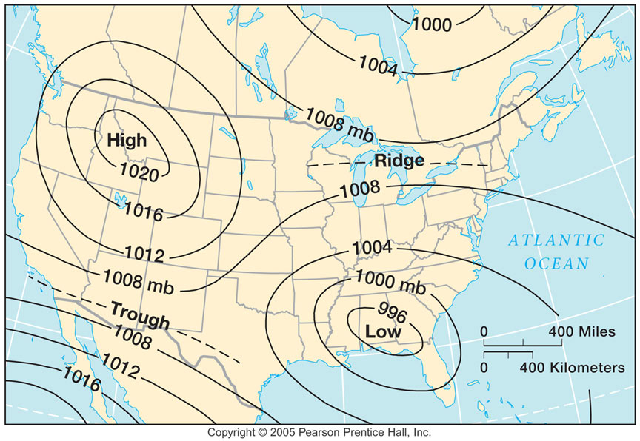

**Thermal Spirals**

**Passport Question:** What causes the air to rise?

**Passport Answer:** Heat

**Background information:**

We feel the wind every day. The air is almost always in motion. One day it may be from the north and the next day from the south. There are many sources for wind: mechanical sources such as fans and, in nature, falling rain as it drags air along. But what is the origin of wind on the earth?

**Supplies:**

Paper plates

Scissors

String

Colored pencils/crayons

Toaster or other heat source

|  |  |
| --- | --- |
| **Set up** | |
| **1** | There are premade spiral paper plates provided with this activity. You or the students can use these premade ones for the activity, or the students can make and decorate their own. |
| **2** | If the student wants to make their own: give the student a paper plate and allow them to use the colored pencils to design their plate (optional). |
| **3** | For the next step use your best judgment on whether the student should cut their own paper plate or if you assist them with this step. Cut the paper plate into a spiral. |
| **4** | Tie a string to the center of the spiral so when you hold it by the string it can hang from the center and spin. |
| **Procedure** | |
| **1** | Turn the toaster on to allow the unit to heat. |
| **2** | Ask the student where wind comes from. |
| **3** | Ask the students if a toaster can create wind. |
| **4** | Hold the spiral paper plates (10-15 inches) over the top of the toaster. What happens? Do not hold it any lower, this is a fire risk. |
| **5** | Turn the toaster off. |

**Discussion:**

* Students may say clouds or trees cause the wind and that toasters cannot produce wind. They will quickly see that toasters do produce wind. Explain that wind is just air molecules in motion.
* We have all heard that “heat rises,” but why? The glowing coils in the toaster produce infrared radiation, heating the toaster. The heated metal then warms the air in the toaster, making the air less dense. Less dense air rises and cooler, denser air moves in to take its place, creating wind that spins the paper spiral.
* The source for the earth's heat is the sun. The radiation from the sun heats the ground. The ground, in turn, heats the air and we know that hot air rises. As it rises, cooler air comes in to replace the rising air. We feel this as wind.
* The faster the air rises, the faster the wind blows to take its place. Every time we feel the wind, regardless if is from the north, south, east, or west, somewhere else around the world the air is rising. The term for this rising air is **convection**. The wind patterns we experience have their source in convection.

**Airzooka (bonus activity)**

* After they have created their thermal spiral and learned that wind is just the movement of molecules they can try their hand at the Airzooka
* The Airzooka is a device that fires a vortex of air when you pull the elastic chord backwards and create a pressure vacuum.
* Explain to students that they can now try to manipulate the movement of molecules in the air to knock the cups over that are placed on the small table behind Thermal Spirals.
* Have the student stand behind the tape line that is about ten feet from the cups.
* Give them 2-3 tries each (The Airzooka can be hard to fire correctly at first).
* Fun online information about air vortices:
  + A large air vortex cannon, with a 9 feet (2.7 m) wide barrel and a displacement volume of 2,873 US gallons (10.88 m3) was built in March 2008 at the [University of Minnesota](https://en.wikipedia.org/wiki/University_of_Minnesota), and was able to blow out candles at 180 feet (55 m).
  + In 2012 a large air vortex cannon was built for [Czech television](https://en.wikipedia.org/wiki/%C4%8Cesk%C3%A1_televize) show *Zázraky přírody* (English: *Wonders of Nature*). It was capable of bringing down a wall of cardboard boxes from 100 meters (330 ft) in what was claimed to be a world record

**Mini Greenhouse Effect**

**Passport Question:** What greenhouse gas is released in this experiment?

**Passport Answer:** CO2

**Background information:**

Earth's atmosphere is composed of a mixture of gases: 78% nitrogen, 21% oxygen, >1% argon and trace amounts of other gases, including carbon dioxide. Some gases absorb and re-radiate infrared energy that we sense as heat. These heat-absorbing gases are often referred to as greenhouse gases. Human activities have been adding carbon dioxide and other greenhouse gases to the atmosphere. How will earth's atmosphere respond to this increase in the amount of greenhouse gases? Scientists create physical models or experiments to compare how systems respond to changing conditions.

In this experiment students will observe two model atmospheres: one with normal atmospheric composition and another with an elevated concentration of carbon dioxide. These two contained atmospheres will be exposed to light energy in a sunny window or from a lamp.

**Supplies:**

Vinegar

Baking Soda

Erlenmeyer flask

Test tube

Stoppers

Connector Tubes

2 thermometers

Black paper

Light/ heat source

2 tanks (or mason jars)

BTB

Small Whiteboard to graph results

|  |  |
| --- | --- |
| **Procedure** | |
| **1** | Intro Questions:   1. Explain to students that air is a mixture of many different gases, including some greenhouse gases that absorb infrared energy. 2. Ask students if they know what a greenhouse is and what it does? 3. Ask students if they know any greenhouse gases and their sources. (Answers may include: Water Vapor; naturally present from evaporation and transpiration. Carbon dioxide; burning fossil fuels, burning forests. Methane; rice agriculture, digestive systems of cattle, decaying organic matter. Nitrous oxide; agriculture through the use of nitrogen based fertilizers, livestock waste). 4. Ask Students: What human activities have been changing the concentration of these gases in our atmosphere? (Answers: see above.) Tell students that over the past 200 years, the concentration of these gases increased from approximately 278 ppm (parts per million) in 1800 to 405 ppm in 2016. 5. How does that happen? Use carbon poster and black “carbon” dots to tell the story of where carbon is emitted and where is it stored.  * Carbon stored (plant mass (through photosynthesis), soil carbon, fossil fuels, oceans) * Carbon released (plant respiration, decomposition, burning fossil fuels) * The earth has had an increase in CO2 release from burning fossil fuels and now there is a lot more carbon in the atmosphere. * Ask students: If we burn fossil fuels what is released? And where does it end up?  1. Show graph of CO2 increase. |
| **2** | http://www.amnh.org/education/resources/rfl/web/climatechangeguide/activities/images/greenhouse_figure1.gif |
|  | Assemble the flask, stopper, and tubing as seen in the illustration (should already be set up for you). |
| **3** | Remove the stopper and have a student place 100 ml of vinegar into the flask and another student add a half teaspoon of baking soda, then replace the stopper. |
| **4** | Place the flexible tubing into the BTB solution and notice the color of the liquid as the gas bubbles through the indicator solution. What color change do you notice? (Answer: Blue to Yellow) |
| **5** | Discuss what gas is being produced; CO2 is a byproduct of the reaction between vinegar and baking soda. |
| **6** | Add 2 teaspoons to the flask to keep reaction happening. Now put the flexible tube into one of the tanks. Allow the tubing to stay in the tank for a minute or so. Ask students what invisible gas we are adding into the tank? (Answer:CO2) |
| **7** | Keep one control (the tank without added CO2) identical to other tank but without added gases. |
| **8** | Record both temperatures every 10 minutes in the table on the white board/graph paper. |
| **9** | Once a few data points have been collected, begin graphing temperature vs. time on the other white board. Continue this throughout the session. (This is optional. There is already a lot going on with this activity so if you don’t get to the graphing portion just make sure students understand that the container with CO2 added has a higher temperature due to its ability to absorb heat). |
| **10** | Data collection and graphing will continue with first tank you did the experiment with. You can continue to show the vinegar and baking soda and BTB experiment to the students as they come by, but there might not be enough time to collect new data. |

**Discussion:**

* As one can see from this controlled experiment, greenhouse gases absorb heat. Our control tank and our CO2 tank were exposed to the same amount of heat from the light and are identical in every other way. The only difference is the CO2 addition.
* The BTB changed color because BTB is an indicator solution. Meaning it will turn yellow in the presence of acid. When CO2 mixes with water it becomes Carbonic Acid. We can see the effect of CO2 acidifying things when we look at our oceans. When too much CO2 gets into the ocean it affects the way crustaceans form their shells. This can, in turn, alter the oceanic food web, which we are a part of. Show them the shells and ocean acidification poster.
* Ask students how they can reduce their carbon footprint!

**Lightning Room!**

**Passport Question:** Lightning is an example of _______ electricity.

**Passport Answer:** static

**Background:**

What is lightning?

Lightning is a bright flash of static electricity produced by a thunderstorm. All thunderstorms produce lightning and are very dangerous. If you can hear thunder, then you are in danger from lightning. Lightning kills or injures between 75 to 100 people each year on average; more than hurricanes or tornadoes.

What causes lightning?  
Have you ever rubbed your feet across carpet and then touched a metal door handle? If so, then you know that you can get shocked! Lightning works in the same way. Lightning is an electric current. Within a thundercloud high in the sky, many small bits of ice (frozen raindrops) bump into each other as they move around in the air. All of those collisions create an electric charge. After a while, the whole cloud fills up with electrical charges. The positive charges or protons form at the top of the cloud and the negative charges or electrons form at the bottom of the cloud. Since opposites attract, that causes a positive charge to build up on the ground beneath the cloud. The ground’s positive electrical charge concentrates around anything that sticks up, such as mountains, people, or single trees. The charge coming up from these points eventually connects with a charge reaching down from the clouds and - zap - lightning strikes!

**Supplies:**

Fluorescent light bulbs

Balloons

|  |  |
| --- | --- |
| **Procedure: Balloons and Light Bulbs** | |
| **1** | Have students grab a blown-up balloon. |
| **2** | Pass out light bulbs, one per student or pairs depending on the number of students. |
| **3** | Have students rub the balloon on their heads to generate static electricity, which builds up due to the friction between the balloon and the students hair. |
| **4** | Turn off the lights and have students press the balloon on end of light bulb. |
| **5** | The light bulb lights up! (Sometimes it takes a few tries before it will light up.) |
| **6** | Repeat if students want to do it again. |

|  |  |
| --- | --- |
| **Procedure: Van de Graaff** | |
| **1** | |  | | --- | | Crank the Van de Graaff generator by hand to produce static electricity. | | While cranking the generator place the big wand within proximity of the large ball at the top of the generator and notice the arc current between the 2 balls. | |  | |

**Discussion:**

* The Van de Graaff generator is an electrostatic generator which uses a moving belt to accumulate very high electrostatically stable voltages. Look at how the rubber belt rubs against the wheel at the bottom of the generator -- as the rubber and wheel come in contact with each other they produce electrons (negatively charged particles) that are captured by the ball; this is also known as static electricity. The small wand is capturing protons (positively charged particles.) Why does your hair stand on end? Because the generator is charging you with electrons and each of the strands of your hair have the same negative charge. Like charges repel each other, so each of your hair strands want to move away from each other.

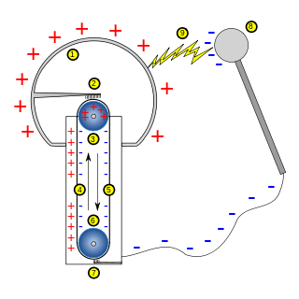

* Rubbing the balloon generates static electricity the same way as the Van de Graaff generator. Friction can separate positive and negative charges. As negative charges build up on the balloon, they attract the positive charges on the wall. The balloon will stay against the wall until all the static electricity is dispersed. Similarly, the fluorescent bulb lights up because of the electrical charge that is conducted from the static electricity, from your hair, and into the bulb.

**This Activity should come before the Rumbling Road as lightning happens before thunder.**

**The Rumbling Road**

**Passport Question:** Which travels faster: light (lightning) or sound (thunder)?

**Passport Answer:** Light

**Background:**

Thunder is a result of the rapid expansion of super-heated air caused by the extremely high temperature of lightning. As the lightning bolt passes through the air, the air expands faster than the speed of sound generating a "sonic boom". Therefore, lightning creates thunder.

Since the sonic boom is created along the path of the lightning bolt, in effect, millions of sonic booms are created, which we hear as a rumble.

Thunder from a nearby lightning strike will have a very sharp crack or loud bang, whereas thunder from a distant strike will have a continuous rumble. The primary reason for this is that the sound shock wave modifies as it passes through the atmosphere.

Sound travels roughly 750 mph (1,200 km/h), or approximately one mile every 5 seconds (one kilometer every 3 seconds). The speed actually varies greatly with the temperature, but the rule of thumb is 5 seconds per mile (3 seconds per kilometer). On the other hand, lightning can travel 220,000 mph.

Through a series of examples, the student will be able to determine the distance to a lightning strike.

**Supplies:**

Flashlight

Thunder sound files or the Thunder stick

Speaker or some kind of sound amplifier

White board

**Procedure:**

|  |  |
| --- | --- |
| **Procedure** | |
| **1** | Instruct the students about thunder and why it occurs. Ensure they know sound travels about one mile every five seconds (three kilometers every three seconds). Instruct the student that they can approximate "seconds" by counting "One-Mississippi", "Two-Mississippi", "Three-Mississippi", etc. |
| **2** | Have the student look at the end of the flashlight and instruct them to begin counting once they see it light up |
| **3** | Rapidly turn the flashlight on and off |
| **4** | After you count five seconds, play the sharp thunder sounds. |
| **5** | Have the students divide the time from the first light to hearing the sound by 5 seconds to determine the distance in miles from the lightning bolt. You can write this on the whiteboard to help them with the math. |
| **6** | Repeat the procedure but wait 10 seconds between flashing the light and playing the sound. (Sharp Rumble) |
| **7** | Repeat the procedure but wait 15 seconds between flashing the light and playing the sound. (Far Rumble) |
| **8** | Repeat the procedure several more times but vary the time from flash to sound (two seconds, 14 seconds, etc.). Remember, the longer the time between flash and sound, the farther away the lightning is so use the thunder sounds (distant rumbles) that, by themselves, are an indication of distance. |

**Discussion:**

* Each time you do the procedure there will be some variability in the student's results due to inconsistent counting of the seconds. However, you will quickly be able to understand the student's grasp of the concept by inquiring how many seconds they counted.

**Rising Sea**

**Passport Question:** Is sea ice melting in the Arctic or Antarctic leading to rising sea levels?

**Passport Answer:** Arctic

**Background information:**

The global sea level is rising over time due to climate change. This is different from the daily rising tides caused by gravitational forces exerted by the Sun, Moon, and rotation of Earth, or by extreme weather events—which are also related to climate change. There are many different changes to the sea level and the coastline. Some of those changes are short-term and regular, like the rise and fall of the tides every day. Some of those changes are short-term and temporary, like storms that create floods on land. And some of those changes are long-term and potentially permanent, like the increase in sea levels due to climate change.

Some participants might think that melting glaciers and ice wouldn’t change the sea level because it would be like an ice cube melting in a cup of water. It can be hard to envision how sea levels can rise because Earth is so big, and there are so many different sources of water and ice. One thing to remember is that there is a lot of ice and snow on top of land, and when it melts it flows into the ocean and adds to the total amount of water in the ocean.

Some participants might dispute climate change. You can respectfully respond, “Yes, not everyone is in complete agreement about climate change. The great majority of scientists agree it is occurring, and have a lot of supporting evidence. We are presenting the scientific perspective on sea level rise in this activity.”

This activity provides a hands-on model of an important change that is occurring on Earth: sea level rise and the corresponding inundation of coastal land by water. Participants will create a topographic map that documents this relationship. As you facilitate the activity, you can ask questions that prompt participant observation and reflection, and provide opportunities for you to share relevant information

**Materials:**

* Basin and landform
* Clear acrylic
* Dry erase marker
* Eraser
* Large pitcher for water
* Blue food dye
* Sponge (or paper towels)
* Observing Earth information sheet
* Two Tupperware models
* A lamp
* Ice and water

|  |  |
| --- | --- |
| **Procedure** | |
|  | **What is causing sea levels to rise?** |
| **1** | **Ask the students what they know about global warming, climate change, and sea levels rising**. You can explain how this activity is going to model what is causing sea levels to rise and how that affects coastlines around the world. **Ask the students if they know what a model is?** A model is a small scale representation of something you are studying. Scientists use models to visualize scientific concepts that would otherwise be more difficult to study. |
| **2** | Show the students the two Tupperware models. These models represent the Arctic and the Antarctic. **Ask them if they know what the main difference is between these two places?** If they don’t know you can hint by asking why is one considered a continent and the other is not. The Arctic is sea ice floating on the ocean, Antarctica is a continent because it is a land mass with ice covering its surface. |
| **3** | In the Tupperware without clay, place ice cubes in water and mark where the surface level is at. This model represents the Arctic. In the Tupperware with clay, fill the bottom with a bit of water and mark where the surface of the water is at. Then place the ice cubes on top of the clay. This model represents Antarctica. |
| **4** | **Ask the students what they predict will happen in these two models as the ice melts.** Leave the two models in front of the lamp while you start the next part of this activity. Come back to it after the students work through the next model. You should be able to see that the water level has increased in the Antarctic model because the ice melt-off is adding to the volume of the water. In the Arctic, the ice was already in the water and therefore does not change the total volume of the water as it melts. |
|  | **What is the effect of the sea level rising?** |
| **1** | Now tell the students that while they wait for the ice to melt they are going to learn how scientists study the effects of the sea level rising on the coastlines. **Ask the students how they think coastlines have been affected by sea ice melting.** |
| **2** | Tell the students the basin and landform is a model of an island in the ocean. Fill the pitcher with water and add a few drops of blue food coloring. Then fill the basin with about an inch of water. |
| **3** | Place the clear acrylic over the basin and have the students to use a marker to trace around the outside edge of the island landform. |
| **4** | After they draw the outside edge, add more water to the basin. Have them draw a new line after each addition of water. Repeat this process 3 or 4 times until they have drawn a topographic map. |
| **5** | **Ask them if they know what topography means or if they have ever seen a topographic map.** Topography is the study of the shape and features of a landform. **You can also ask them if they understand what the addition of water represents in this model.** Adding more water between each line represents how much the sea level is rising due to ice melting. |
| **6** | After they have drawn their map, **ask the students if they know what the lines represent on the clear acrylic.** They have drawn a topographic map that represents how much the coastline has changed on this island due to rising sea levels. Make sure they know that this is not a typical topographic map. This map is different because each line they drew represents the coastline at different points in time, rather than showing the topography of the island at one point in time. Their map shows how the coastline has changed as the sea level rises. There could be months to years between each line that they drew. |
| **7** | **Ask them to explain how all three of these models relate.** As the average global temperature rises, more of the glaciers in Antarctica are melting which contributes to rising sea levels. As the sea level rises, the coast lines are being affected dramatically. Scientists can monitor and asses these issues by using models and by mapping the change in coast lines. |

**Discussion:**

Ask them why they think it is important to track the changes in the coastline?

Rising sea levels will have consequences for life around the world. Many people and animals depend on the ocean and on stable coastlines. Man of the world’s largest cities are found on coast lines. As the sea level rises, these cities will be directly affected.

In the model, the water is raising in the basin because the sea level is rising. Why that is occurring on Earth right now? What are other causes of sea level rising?

Rising sea levels are caused by climate change. As the Earth warms, the ocean absorbs heat and expands. Glaciers and ice sheets on land melt, adding water to the ocean. Within our lifetime, we’ll see major changes to ocean coastlines.

Ask the students what they know about NASA and what they study (many students will be surprised to learn that NASA studies the Earth, not just space).

Scientists are monitoring sea levels, providing information that can help us prepare for and adapt to changes. Researchers keep a long-term record of sea surface height to predict how rapidly sea levels are rising and how those changes will affect coastal areas and communities. For example, NASA’s Jason-3 spacecraft uses radar to measure the height of the ocean. The satellite also records wind speeds and wave heights. These data help scientists determine how climate change is affecting the world’s oceans and develop accurate models of what will happen in the years to come. It’s up to all of us to take this information into account and plan for the future.

**Investigating Albedo**

**Passport Question:** What absorbs more heat, dark pavement or a snowy glacier?

**Passport Answer:** Dark pavement

**Background:**

What Is Albedo? While the Earth’s temperature is dependent upon the greenhouse-like action of the atmosphere, the amount of energy retained by the Earth is strongly dependent on the albedo of Earth surfaces. Just as some clouds reflect solar energy into space, so do light-colored land surfaces. Scientists use the term **albedo** to define the percentage of solar energy reflected back by a surface. This surface-albedo-effect strongly influences the absorption of sunlight. Forests, grasslands, ocean surfaces, ice caps, deserts, and cities all absorb, reflect, and radiate solar energy differently. Sunlight falling on a white glacier surface strongly reflects back into space, resulting in minimal heating of the surface and lower atmosphere. Sunlight falling on dark soil or rocks is strongly absorbed, and contributes to significant heating of the Earth’s surface and lower atmosphere.

Understanding local, regional, and global albedo effects is critical to predicting global climate change. Light colored ice and snow are very weakly absorptive, reflecting 80-90% of incoming solar energy. Dark-colored land surfaces, are strongly absorptive and contribute to warming, reflecting only 10-20% of the incoming solar energy. If global temperatures increase, snow and ice cover may shrink. The exposed darker surfaces underneath may absorb more solar radiation, causing further warming. The magnitude of the effect is currently a matter of serious scientific study and debate.

**Supplies:**

2 Lamps with 150 watt bulb

2 Laser Thermometers

Satellite images of cities from space and glaciers

Images of the globe in winter/summer

**Procedure:**

|  |  |
| --- | --- |
| **Procedure** | |
| **1** | Ask students if they have ever noticed that wearing a black shirt on a warm, sunny day made them hotter. Ask them if they have noticed that they are hotter when standing on blacktop pavement/asphalt or a paler cement surface. Why is that the case? Discuss how dark surfaces absorb light (or the sun’s energy and transforms it into heat energy. |
| **2** | Ask students what they think might happen if the Earth was wearing a white or black tee-shirt. Of course, the Earth cannot wear a tee-shirt and, the color of the Earth’s surface is not the same everywhere. Show students the pictures of the globe. What colors do they see? Which parts of the Earth are the lightest colors? Which are the darkest? Where do they expect that most sunlight will be absorbed? Where do they expect that the least sunlight will be absorbed? |
| **3** | Have groups look at the laminated world map. Ask students what they see in the picture. The dark parts of the map could be land or ocean. The white sections are ice and snow. Most of our ice and snow is held at the poles and in glaciers. Explain what a glacier is (persistent body of dense ice that is constantly moving under its own weight; it forms where the accumulation of snow exceeds melting and sublimation over many years, often centuries). |
| **4** | Ask students to make a hypothesis about which areas of the photograph they think would absorb the most solar energy and which would absorb the least. |
| **5** | Have one lamp over one picture of the globe. Have the other lamp over the other picture of the globe. |
| **6** | Turn the lamps on over the pictures, wait about a minute and have the students examine the difference in temperature over different colored areas on the map using the laser thermometers. Ask the students if their hypothesis was correct. The dark colored area should get hotter faster. After about a minute or two turn the lamps off. |
| **7** | You can then add a clear transparency over the picture of the earth. The pictures should get hotter a little faster. |
| **8** | Have them examine temperatures again. You should see the dark areas getting hotter even faster. The light areas will get hot as well. |
| **9** | You can then experiment with the other laminated pictures and discuss the difference between asphalt and grasslands. We sometimes pave over grasslands to build parking lots. How does this influence albedo? |

**Discussion:**

Point out how this model is different than the real world (For example, would either ice or the land surface ever get to those temperatures?) This model shows relative differences based on the color of the surface but does not take into account the type of material or its reflective abilities. Explain that ice is melting. How would less ice affect the system?

In our lake conditions app we can check the temperature of different places around the lake. We have placed temperature sensors at these locations in order to study how temperature in those places changes by season. The sensor placed near to Zephyr cove always reads about 10-15 degrees hotter than the other stations. Why do you think that is?

*The station is always 10-15 degrees hotter because it is placed right next to an asphalt surface whose radiant heat is warming the sensor. If it were next to a lighter colored surface, the reading would be much cooler.*

***Why did we add the sheets of clear plastic?***

We added the plastic to simulate a thicker atmosphere. Similar to our atmosphere, the sheets of plastic trap heat but also let some heat out. The more greenhouse gases we add to our atmosphere the thicker it will become and the more heat it will retain.

Domino Effect – As the globe warms and the earth becomes hotter, more and more of our ice and snow will melt. Buried underneath much of our ice and snow is dark colored rock. As the reflective snow and ice is melted, the darker rock underneath will absorb more heat and in turn melt the surround ice at an even faster rate. This is known as a domino effect, one change leading to another, which leads to another and so on, and so forth.

These dark and light colors can cause something called the urban heat island effect. When we alter the natural landscape by building cities we change the reflectivity of the surface. By building dark colored structures we can actually raise the temperature of a city by several degrees. Sometimes, the temperature spikes can be so high that they are harmful to organisms living in the city, even to humans!

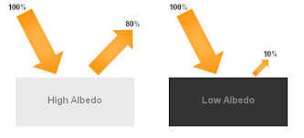

**Space Science**

**How Big is the Moon?**

**Passport Question:** The Moon is much smaller than Earth and the Sun, but it can still block the Sun during a total **solar / lunar** eclipse because of perspective. (Circle one)

**Passport Answer:** The Moon is much smaller than Earth and the Sun, but it can still block the Sun during a total **solar** eclipse because of perspective.

**Background Information:**

The Moon is only **1/50th** the size of Earth in terms of volume! That means if Earth were hollow you could fit 49 Moons inside it. The Sun’s volume is roughly **1.3 million (1,304,000) times** greater than Earth's and **6.4 million** (**63,926,940) times** greater than the Moon’s.

Even though the Sun is much larger than the Moon, they appear the same size in the sky, and the Moon can completely block the Sun during a **total solar eclipse**. It’s all a matter of perspective! Because the Moon is much closer to Earth than it is to the Sun, when the Moon passes in between Earth and the Sun, it can block the Sun’s light by casting its shadow on Earth.

**Training Video:** <https://vimeo.com/191171673>

**Materials:**

* Play-Doh
* Butter Knives
* Templates with 50 rectangles labeled 1-49 (Earth) and 1 (Moon)
* Images of solar eclipse
* Image of Sun to place on the wall

|  |  |
| --- | --- |
| **Procedure** | |
| **1** | Ask students: *Which is bigger, Earth or the Moon?* Ask them to guess how much bigger. This is their hypothesis. Ask: *Which is bigger, Earth or the Sun?* |
| **2** | Take a piece of Play-Doh and roll it into a long cylindrical shape. Set the Play-Doh against the template and cut it at the grey “Moon” rectangle so that you have two pieces, one 49 units long, and the other 1 unit long. |
| **3** | Roll each of the pieces into spheres. The large piece is Earth and the small piece is the Moon. Ask students: *Are you surprised?* Tell them ***the Moon is 50 times smaller than Earth.*** Ask students: *How about the Sun? How big would it be in comparison?* Tell them: ***On this scale, the Sun would need 64 million pieces of Play-Doh!*** |
| **4** | Ask: *Has anyone seen a solar eclipse before?* Prompt students about the 2017 eclipse, if they remember it. Ask *does anyone know what causes a solar eclipse?* Show a picture of the solar eclipse. *A* ***solar eclipse*** *is when the Moon crosses between Earth and the Sun, blocking the Sun’s light and casting a shadow on Earth.* *How can our tiny Moon block the giant Sun during an eclipse?* |
| **5** | Have students think about how someone seems smaller when they are far away and bigger when they are closer. Another fun example is “squishing” someone’s head between your thumb and pointer finger when they stand far away from you. Clearly, their head is much larger than your fingers but you are able to “squish” their head because they are so far away. |
| **6** | Tell students to block the Sun image on the wall using either their Earth or Moon models (NOTE: This part of the activity is not to scale. The Sun would actually be much larger than the picture, but the scientific concept still holds.) Tell them they are Earth and their Play-Doh moon is the Moon. Allow them to experiment and figure out how to eclipse the Sun with the Moon. |
| **7** | Answer any questions, and prompt them to think about the discussion points below: |

**Discussion:**

* The Sun and Moon appear nearly the same size in the sky because the Sun's diameter is about 400 times larger than that of the moon and the Sun is also about 400 times farther from Earth.
* The average distance between Earth and the Moon is 250,000 miles. For comparison, the next closest object is Venus with an average distance of 25,000,000 million miles. The distance from Earth to the Sun is 92,170,000 million miles. In astronomical terms, the Moon is right on top of us!
* Total solar eclipses are very rare—they are only possible when the Moon is crossing Earth’s orbital plane, which only happens twice a year, AND is in the new Moon phase. They often occur in the middle of the ocean, so it is even more rare when they are visible from cities and towns on Earth. You may remember the total solar eclipse when the Moon’s shadow crossed the United States in 2017!
* A **total solar eclipse** is what we most often refer to as an “eclipse.” A lunar eclipse is when Earth is directly between the Sun and the Moon, causing the moon to appear reddish in tint, which is why it is sometimes called a blood moon!
* Partial solar eclipses occur when the Moon is not directly in the Sun’s path, but still casts a shadow visible from Earth.

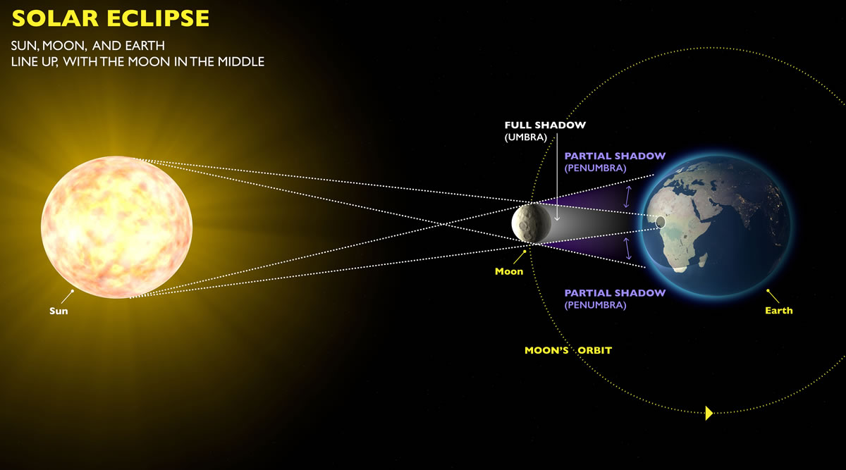

**Pocket Solar System**

**Passport Question:** Name the planets in our solar system in order of their distance from the Sun:M__, V__, E__, M__, J__, S__, U__, N__

**Passport Answer:** Name the planets in our solar system in order of their distance from the Sun: Mercury, Venus, Earth, Mars, Jupiter, Saturn, Uranus, Neptune.

**Background Information:**

What does our solar system look like? Building scale models of the solar system is a challenge due to the vast distances and huge size differences involved. This is a simple, small model to give students an overview of the distances between the orbits of the planets and other objects in our solar system.NOTE: While the distances are to scale, the planet images we use are not.

**Materials:**

* 1 completed Pocket Solar System for reference
* 1 meter per person of receipt paper
* Meter stick
* Planet sheet
* Scissors
* Glue sticks
* Recycling bin
* Folding guides: 2 English, 1 Spanish, 1 Pink Facilitator Guide
* Decorations: solar system poster, images of planets to scale, mnemonic device posters

**Training video:** <https://vimeo.com/191168509>

**More planet information:** <https://solarsystem.nasa.gov/>

|  |  |
| --- | --- |
| **Procedure** | |
| **1** | Ask the students: *Do you know the order of the planets? Which planet is furthest from the sun? Which planet is closest to Earth?* |
| **2** | Give each student a meter length of paper tape, a sheet of planets, scissors, and a glue stick. Tell the students *We’re all going to do each step of this together.* Instruct students to cut around the planets as small as possible while still retaining the planet name.) Students can cut the planets out at the beginning or as they do the activity. Use the pre-made pocket solar system and the pink folding guide as a reference. |
| **3** | Have them place the Sun at one end and the Kuiper Asteroid Belt at the opposite end. (Note: Pluto was reclassified from a planet to a dwarf planet in 2006. It is a part of the Kuiper Belt.) |
|  | Fold the tape in half and crease it. Unfold and lay it flat. Ask students which planet they think will be right in the middle and why. They might be surprised to know that the planet that goes at the **½ mark is Uranus** (Note: Pronounce this planet “your-in-us”). |
|  | Refold the paper in half and fold it in half again (you should now have fourths). At the halfway point between Uranus and the Kuiper belt, place **Neptune (3/4 mark)**. |
|  | At the halfway point between Uranus and the Sun, place **Saturn (1/4 mark)**. |
| **4** | Stop and inspect your work. *We’ve only placed the 3 most distant planets. That means that we’ve still got 5 planets and the asteroid belt to fit into the quarter between the Sun and Saturn!* |
| **5** | Fold the Sun up to Saturn and crease it. Unfold and lay flat again. Place **Jupiter** at the halfway mark between the Sun and Saturn **(1/8 mark)**. If you take a look, you’ve got the four gas giants on there. For the remaining bodies in the Solar System, you’ll only need inner 1/16th of your tape length! |
| **6** | Fold the Sun out to meet Jupiter to mark the **1/16 spot**. A planet does not go here, but the **Asteroid Belt** does. Explain that many things besides planets orbit the Sun, including asteroids and comets. |
| **7** | At this point, things start getting a little crowded, folding is tough, and it’s hard to get precise distances. (Note: it’s best to stagger the planets to fit the remaining ones. Don’t place them all in a straight line.) Fold the Sun to the Asteroid Belt mark and crease it. Place **Mars** on this **1/32** fold (between the Sun and Asteroid Belt). |
| **8** | *How many more planets do we need to place?* Three. Fold the Sun up to meet the line for Mars. Leave it folded and fold that section into an even smaller half. Unfold the tape and you should have three creases. *Do you know the order of the remaining planets? Make some guesses.* Place **Earth** on the **3/128** crease nearest Mars, **Venus** on the middle **(1/64)** crease, and **Mercury** on the **1/128** crease closest to the Sun. |
| **9** | Smooth out your model and admire your work. *Are there any surprises when you look at the distances between the planets this way?* Many people are unaware of how “empty” the outer solar system is (there is a reason they call it space!) and how “crowded” the inner solar system is (relatively speaking). *How was this different from what you imagined?* |
| **10** | Tell students they can keep this pocket solar system to remember how far apart the planets are. Then direct them to the **mnemonic device or “memory sentence”** posters. Explain that they can make up a sentence to help them remember the order of the planets. A common one is “My very educated mother just served us nachos.” Our sentence will include a “K” word at the end for the Kuiper Belt. Tell them they can write their own “memory sentence” on the back of their pocket solar system using the words on the wall, or they can make up their own. |

**Discussion**

* The Sun is the only star in our solar system (there are no other stars sprinkled throughout.)
* The solar system is inside the Milky Way Galaxy (not in the center), which is part of the universe (but also not “in the center”). Students may confuse these vocabulary words and use them interchangeably.
* The large amount of space between planets still contains things like dust, plasma, and light, so it isn’t truly “empty.”
* Our **Solar System** is made up of planets, moons, asteroids, comets and other objects that orbit the Sun.
* Many of the planets in our solar system are relatively close to the sun, while the Gas Giants (Jupiter, Saturn, Uranus, and Neptune) are much further.
* There are eight planets in the Solar System. Pluto, the former ninth planet, was renamed a “dwarf planet” in 2006 due to its small size (it’s smaller than our Moon!).
* Notes from NASA on Pluto: “Pluto is a dwarf planet that lies in the Kuiper Belt, an area full of icy bodies and other dwarf planets out past Neptune. Pluto is very small, only about half the width of the United States and its biggest moon Charon is about half the size of Pluto. Almost all the planets travel around the Sun in nearly perfect circles. But not Pluto. It takes an oval-shaped path with the Sun nowhere near its center. What's more, its path is quite tilted compared to the planets.”
* Although we usually think of the Solar System as planets, there are many other objects orbiting the Sun. The Asteroid Belt is a loose collection of rocky asteroids orbiting between Mars and Jupiter. Astronomers believe they are leftover materials from the formation of the Solar System that never came together to form a planet or moon.

**Cooking Up Comets**

**Passport Question:** Name two ingredients that make up comets.

**Passport Answer:** Ice, frozen gases, rocks, dust, organic material

**Background Information:**

**Comets** are small objects that orbit the Sun and are made of frozen water, rocks, dust, and frozen gases such as ammonia, methane and carbon dioxide. They are created from some of the materials left over after the formation of planets. Much of these materials were lumped together to form planets. But, the remaining amounts circulated in the outer edges of our solar system where temperatures were cold enough to produce ice. In this activity you will “cook” a comet to show what one might look like up close.

**Ingredients:**

* Water (1 cup)
* Dry Ice
* Sand
* Ammonia
* Molasses or dark corn syrup

**Materials:**

* Cooler
* Hammer
* Heavy Duty Yard Trash Bag
* Construction Gloves
* Metal Bowls (2)
* Large Metal Spoon
* Measuring cup
* Lab Coat and Goggles

**More information on Comets vs. Asteroids**: <https://spaceplace.nasa.gov/asteroid-or-meteor/en/>

<https://solarsystem.nasa.gov/asteroids-comets-and-meteors/meteors-and-meteorites/in-depth/>

|  |  |
| --- | --- |
| **Procedure** | |
| **1** | Put on safety goggles and gloves! This activity involves dry ice and **students must not touch the comet with their bare hands.** Say: *Everyone needs to be conscious about safety! I am wearing my Personal Protective Equipment (PPE) that includes gloves and goggles. Whoever handles the dry ice must wear PPE.* |
| **2** | Have all ingredients and utensils arranged in front of you. Cut open a garbage bag and use it to line your mixing bowl. **A comet is a body of ice, rock, organic material, and dust that can be several miles in diameter and orbits the sun.** *As our Solar System cooled, it gathered dust to make small rocks which then gathered together to make even bigger rocks, which ended up forming the planets and moons! Comets are the leftover bits of frozen water and rock that were not incorporated into larger planets and moons. Think of them as the bits of dough left in the bowl when you make cookies!* It may help to distinguish the differences among comets, meteors, asteroids, etc. using the definitions and pictures provided. |
| **3** | Place **1 cup of water** in mixing bowl. *The water in comets is frozen*  *because it is so cold in space.* |
| **4** | Add **one spoonful of sand**, stirring well. *You can’t buy interplanetary dust at the store. So, we have to use sand in its place! Luckily, sand has the same minerals and compounds found in comets.* |
| **5** | Add a **dash of corn syrup**. *This represents organic material. Organic material means anything made up of carbon, hydrogen, nitrogen and oxygen! Every living thing on Earth is made of organic material.* |
| **6** | Add a **dash of ammonia**. Stir while talking. *Ammonia is another organic compound found in comets. When you help clean the windows, it’s with some of the same chemicals found in comets!* Continue to stir until well mixed. |
| **7** | **Be sure to wear gloves while handling dry ice.** Take a **large chunk of dry ice** out of the cooler and place in a separate garbage bag to smash. Use the hammer and smash the dry ice to a “snow cone consistency.” Take approximately 1 cup of the dry ice and add it directly to the mixing bowl. |
| **8** | Stir vigorously. *Dry ice is frozen carbon dioxide, the same gas that makes bubbles in soda. When a comet is far from the Sun, its carbon dioxide is frozen into dry ice just like this!* Continue stirring until mixture is almost frozen. *We are stirring up this comet because that is just like the rotation of the comet as it orbits through space around the sun.* Lift the comet out of the bowl using the plastic liner and shape it as you would a snowball. Unwrap the comet as soon as it is frozen enough to hold its shape. |
| **9** | *Observe the comet!* As it begins to melt, the students may notice small jets of gas coming from it. These are locations where the gaseous carbon dioxide is escaping through small holes in the still frozen water. This is also detected on real comets, where the jets can sometimes expel enough gas to propel the comet in another direction and change its orbit. |

**Discussion:**

* Comets have several distinct parts:
  + a nucleus made of ice, frozen gases, dust, small rocks, and organic material, usually 1-10 km in diameter;
  + a coma which is a dense cloud of water and gases that have evaporated from the nucleus;
  + a long **dust tail** made of tiny particles evaporated from the nucleus, which reflects Sunlight and is the most visible part of the comet; and
  + a very long **iong tail** composed of electrically charged gas molecules pushed away from the nucleus by solar wind.
  + hydrogen envelope—trails along between the dust tail and the ion tail;
* Comets are invisible most of the time except when they are near the Sun because they need Sunlight to reflect off of their particles to be seen. They don’t give off their own light.
* Most comets have elongated elliptical orbits that take them close to the Sun for a part of their orbit, and then out into the further reaches of the Solar System for the remainder.
* Some scientists believe that comets were the source of Earth’s water and possibly organic compounds during our planet’s early formation approximately 4.5 billion years ago.
* Comet: A body of ice, rock and dust that can be several miles in diameter and orbits the sun. Debris from comets is the source of many meteoroids.
* Meteoroid: A small rocky or metal object, usually between the size of a grain of sand or a boulder, that orbits the sun. It originates from a comet or asteroid.
* Meteor: A meteoroid that enters the earth’s atmosphere and vaporizes. Also called a “shooting star.”
* Meteorite: A meteor that hits Earth without burning up in the atmosphere.
* Meteor shower: A collection of meteors visible when Earth passes through a trail of debris left by a comet.
* Asteroid: An object larger than a meteoroid that orbits the sun and is made of rock or metal.

**Meteorite Impact!**

**Passport Question:** Name two variables that affects the size and shape of a crater

**Passport Answer:** Size of meteorite, speed of meteorite, angle of impact

**Background Information:**

A **crater** is the remains of a collision between an asteroid, comet, or meteorite and a planet or Moon. Craters can be found on many planets including Mercury, Venus, Earth, and Mars. The size, speed, and angle of the falling object determine the size, shape, and complexity of the resulting crater. Small, slow objects have a low energy impact and cause small, simple craters. Large, fast objects release a lot of energy and form large, complex craters. Very large impacts can even cause secondary cratering, as ejected material falls back to the ground, forming new, smaller craters. In this activity students will experiment to see how craters of different shapes and sizes are formed.

NOTE: How to set-up the Moon model. This should already be done prior to volunteer’s arrival. Directions: In a pie pan, create the surface of the Moon by filling the pan first with flour (about half of the large sifter) and then sift cocoa powder (about half of the small sifter) over the top to create contrast.

**Materials:**

* 9” Pie Pans (6) or larger trays
* Flour (~5 lbs. per day)
* Cocoa Powder (2-3 containers)
* Fine Sifter
* Hand Strainer
* Golf Balls (6)
* Marbles of different sizes (6)
* Ping-Pong Balls (6)
* Small, Non-Spherical Rocks or Pebbles (6)
* Rulers (6)
* Bucket (3 gal)
* Drop Cloth
* Meteorite Impact! Data sheets
* Images of Moon’s surface, craters on Earth, and secondary craters

|  |  |
| --- | --- |
| **Procedure** | |
| **1** | *Have you noticed the craters in the moon? Craters are caused my* ***meteorites*** *that hit the surface of the moon and create a dent. Craters can be big, small, oval-shaped, circular, deep, or flat. Show students an image of the surface of the moon. Ask if anyone wants to make a* ***hypothesis*** *about what causes the different shapes and sizes of the craters.* |
| **2** | Explain that to test a hypothesis we need to change the **independent variables** *one at a time.* Brainstorm some variables we could change (the height the meteorite is dropped, the angle of impact, and the size, shape, and type of meteorite). Have the students make hypotheses before dropping any “meteorites.” Be sure that they change **only one independent variable** at a time. Introduce the activity sheets here. You can even do a quick demo by filling out your own sheet and dropping a ball. Warn students to be responsible with the “meteorites” or the “Moon surface.” |
| **3** | Begin the experiment! Use a ruler to measure the drop height and the diameter of the crater. Be sure to record the results! Let the student do this for a few minutes. You can monitor their progress by making sure they are filling out their sheets and not making a mess. |
| **4** | *Were the students’ hypotheses correct? Why or why not? What have they learned about how craters are formed?* |
| **5** | Compare the surface you created to the pictures of the surface of the Moon. *Using what you now know about craters, what can you tell from looking at these images?* |

**Discussion:**

* Meteorites hit at a wide range of speeds, but the average is about 12 miles per second.
* Erosion from wind and water on Earth has worn away existing craters, making them less visible.
* The surface of the Moon is scarred with millions of impact craters. Unlike Earth, there is no atmosphere on the Moon to help protect it from potential impactors. Most objects from space burn up in Earth’s atmosphere, making meteors.
* Since there is no erosion and little geologic activity to wear away the craters on the Moon, they remain unchanged—until another object hits!
* Most of the craters on the Moon are circular, but some are more oblong-shaped.

**Jumping on Jupiter**

**Passport Question:** Our weight changes on other planets because each planet has a different __________ which affects its __________.

**Passport Answer:** Our weight changes on other planets because each planet has a different mass which affects its gravity.

**Background Information:**

How far you can jump and your weight depend on **gravity**. Gravity depends on a planet’s **mass**—or how much STUFF it’s made of. Smaller planets usually have less mass and therefore less gravity so you weigh less and can jump farther than you can on Earth. Larger planets usually have more mass and more gravity so you weigh more and can’t jump as far or high as you can on Earth. Students will demonstrate this with some simple calculations and a demo with spheres of different masses.

NOTE: It is recommended to take the containers of beans from the Jumping on Jupiter activity to help illustrate the impact of mass on gravity.

**Materials:**

* Scale
* Tape Measure
* Blue Painter’s Tape: tape out 3 meters on the floor and label
* “Jumping on Jupiter” worksheets
* Pencils
* Calculators (6)
* Solar System poster
* Poster-sized graph paper (one for Earth and one for Jupiter, axes labelled ahead of time)
* Stickers in four colors (red=3rd, yellow=4th, green=5th, black=adult)

|  |  |
| --- | --- |
| **Procedure** | |
| **1** | Show students the solar system poster. *On which planet do you think you can jump the farthest? Why?* |
| **2** | Have students line up on the starting line one at a time and challenge them to see how far they can jump on Earth! Make sure that they note where they land. Give students the correct color sticker for their grade level and help them graph their jump on the “EARTH” graph. |
| **3** | Tell them*, you can jump farther on different planets because there is less gravity holding you down*. Look at the “Jumping on Jupiter” worksheet and complete the chart to determine how far you can jump on each planet. |
| **4** | Check their work before they can take the same colored sticker and place it on the “JUPITER” graph. Tell students they can check back throughout the day to see if anyone beats their jumping record. |
| **5** | If time permits: *Based on what you just learned, on what planet do you think you would weigh the most? Why?* See how much you weigh on Earth and complete the opposite side of the worksheet. |
| **6** | *On what planet could you jump the farthest? Were your predictions correct?* |
| **7** | *If your body stays the same, why does your weight change on each planet?*  Hint: *What do you notice about the planets where you weigh more?* |
| **8** | Bonus question: *What do you think you would weigh in space?* |

**Discussion:**

* *What is the difference between weight and mass?* We often use the words "mass" and "weight" as if they were the same, but to an astronomer or a physicist they are completely different things. The mass of a body is a measure of how much matter it contains. **Matter** is anything that takes up space—it can be a solid, liquid or gas. You, me, the lake, the air, Earth, they are all made of matter and have mass.
* Weight is related to mass. Simply put, weight = mass x gravity. You can measure your weight by standing on a scale—the force of Earth’s gravity pulling on you is your weight!
* *So what is the difference between mass and weight?* Your mass is always the same no matter where you are, but your weight changes depending on the gravity of planet you’re on.
* Space by definition is empty—it has no matter. Without matter it can’t have mass or gravity. In space, your weight would be zero!

**Moon Dance**

**Passport Question:** An object spinning around on its axis is ________. An object circling around another object is _________.

**Passport Answer:** An object spinning around on its axis is rotating. An object circling around another object is orbiting.

**Background Information:**

A **rotation** is an object spinning around on what is called an **axis** (an imaginary line down the middle). It takes a day for Earth to do one full **rotation** on its **axis**.

An **orbit** is when an object circles another object, such as Earth going around the Sun. It takes a year for Earth to **orbit** the Sun. Just as Earth orbits the Sun, the Moon orbits Earth.

The Moon doesn’t make any of its own light—it only reflects light from the Sun. In this activity we will see how this reflected light causes the phases of the Moon.

**Materials:**

* Flashlights (1 for each pair of students)
* Styrofoam spheres
* Toothpicks

|  |  |
| --- | --- |
| **Procedure Part 1: Space Carousel** | |
|  | *Before beginning the main activities (Moon Dance and Time of the Seasons), there are three important concepts to make sure everyone knows:* ***rotation****,* ***axis****, and* ***orbit****.* |
| **1** | Have the students stand in a circle around you in the room. Tell them to turn around in place. *What is a scientific word for what you are doing?* **Rotation.** *Does Earth rotate?* Yes. *How long does its rotation take?* One day. |
| **2** | If you could draw a line down the center of your rotation, *where would it be?* They should indicate down the center of their bodies. This time, hold your right arm straight over your head and then rotate. *What does your arm represent?* Your **axis**, the imaginary line right down the middle of a rotation. |
| **3** | Now, ask the students to walk around the circle. *What is a scientific word for this?* It’s an **orbit**. An orbit is when an object circles around another object regularly. *Does Earth orbit?* Yes. *How long does its orbit take?* One year. |
| **4** | Earth rotates and orbits at the same time. Have the students complete another orbit while rotating! *So, what’s the difference between an orbit and a rotation?* |

|  |  |
| --- | --- |
| **Procedure Part 2: Moon Dance** | |
| **1** | *Ask students why the Moon looks different every night*. *What is a new Moon?* Once, or sometimes twice, a month the Moon disappears from our view. This is called a **new Moon**, and it happens when the illuminated side of the Moon faces away from us. *What is a full Moon?* At a **full Moon**, Earth, Moon, and Sun are in approximate alignment, just as the new Moon, but the Moon is on the opposite side of Earth, so the entire Sunlit part of the Moon is facing us. The shadowed portion is entirely hidden from view. |
| **2** | Group the students in pairs and give each pair a flashlight and a sphere. The person with the flashlight is the Sun, the person with the sphere is Earth, and the sphere is the Moon. |
| **3** | Give directions to the students: Each pair stands facing each other a few feet apart. Earth holds the Moon in front of them at arm’s length and a little above their head. The Sun holds the flashlight a little above their head and shines it straight at the Moon. |
| **4** | *Ask Earths to describe what the Moon looks like to their partner*. |
| **5** | Tell Earths to rotate very slowly to their left, holding the Moon in the same position. The Suns should stand still and continue shining the light straight at the Moon. *Ask Earths to stop every two small steps and describe what the Moon looks like. What do they see?* |
| **6** | Once Earths have rotated all the way around, they switch roles with their partners. The new Earths do the same activity, describing the Moon as they slowly rotate. |
| **7** | Have the students discuss these questions with their partners and then ask a few people to share their answers:  *Where is the Moon when we see a new Moon? Where is it when we see a full Moon?*  *Where does the Moon’s light come from?*  *Why does the Moon’s appearance in the night sky change?*  *How would you eclipse your Moon?* |

**Discussion:**

* As the Moon orbits our planet the amount of Sunlight it reflects changes. When the Moon is on the far side of Earth the Sun’s light hits the side facing us, causing a full Moon. When the Moon is between Earth and the Sun, the side facing us is dark, causing a new Moon.
* When the Moon is less than half full is it a crescent; half full is a quarter (because it is ¼ through its cycle); and more than half full is called gibbous. As the shape grows from new to full it is waxing, and as it shrinks back to the new Moon it is waning. In the Northern Hemisphere the Moon is waxing when the lit area is increases from the right to the left. Which means it’s waning when the lit area is decreases from the right to the left. Therefore you can tell if the Moon is waxing or waning based on whether the right side of the Moon is dark or light. Waxing = Right side lit, Waning = Left side lit. In the Southern Hemisphere the effect is just the opposite!)
* *Why do we always see the same side of the Moon?* The Moon orbits Earth because it is pulled by the planet’s gravity. Earth’s gravity “drags” the Moon so that it rotates at the same speed as it orbits (both of which take about 27 days). So we always see the same side! The “dark” side of the Moon is the side that we never see from Earth, although it’s not actually dark—it’s lit up during the new Moon.

**Time of the Seasons**

**Passport Question:** What causes seasons on Earth to change?

**Passport Answer:** The tilt of Earth’s axis.

**Background Information:**

We all know that it is cold in the winter and hot in the summer, but have you ever thought about why that is? People hold a lot of misconceptions about what causes the seasons and this activity will teach the scientific reason for the seasons.

The seasons are caused by the tilt of Earth’s axis. Earth holds its tilt fixed in space as it moves around the Sun. Our planet is tilted at 23.5 degrees and is “pointing” towards the North Star, Polaris.

**Materials:**

* Lamp
* 4 large Styrofoam spheres
* 4 rubber bands
* 4 stands
* 4 thumbtacks
* Protractor
* Station markers labeled December 21, March 21, June 21, and September 21
* North Star image

|  |  |
| --- | --- |
| **Procedure** | |
|  | *Students have just learned about rotation, axis, and orbit and how the Sun’s light creates the phases of the Moon. Now they will see how the Sun cause the seasons.* |
| **1** | Ask the students what they know about the seasons. *Why do we have seasons?* Let students answer without correcting them. |
| **2** | Divide the students into four groups and give them an Earth model. On this model the sphere represents Earth, the dowel is the axis, the rubber band is the equator, and the thumbtack is our location in Tahoe. (*You can also ask students what they think each component represents before explaining*.) *Where is Earth’s* ***axis****? What do you notice about it?* |
| **3** | Place the model near the Sun (the lamp) and with the axis pointing toward the image of the North Star (behind December). Have each group slowly turn the dowel so that Earth spins to the left for one rotation. *Ask them to make observations about the dot with their group.* |
| **4** | They should see that the dot is in light (day) for about half of the rotation and is in shadow (night) for about half of the rotation. This **rotation** is called a day! |
| **5** | Now place one group at each of the dates: December 21, March 21, June 21, and September 21 (see setup below). Have each group model a day at each position, making sure that Earth’s axis is tilted towards the North Star. Students should make observations with their group. |
| **6** | *For what fraction of the day is the dot in the light? More than half? Less than half? About half? How is the light from the Sun striking the dot? Is it direct or at an angle?* |
| **7** | After a couple of minutes, move the groups to the next date and have them discuss the same questions. Do this until they are back at the date they started at. It is very important that Earth’s axis is tilted towards the North Star each time! |
| **8** | *What have you modeled?* A year is the time it takes for Earth to **orbit** the Sun. |
| **9** | *Which group is in summer (June 21)? How do you know (besides the date)? How does the Sunlight hit the dot and for how long? Which group is in winter (December 21)? How does summer and winter Sunlight compare to spring and fall Sunlight?* |
| **10** | Based on your observations, *what causes the seasons on Earth?* To further show the point, take one Earth out of the stand and have it orbit with the axis straight up. *Would we have still have season if Earth’s axis was like this?* |
| **11** | Bonus questions: *Are the seasons in the Southern Hemisphere the same? Why or why not? What happens to the North Pole in winter? Summer? Why?* |

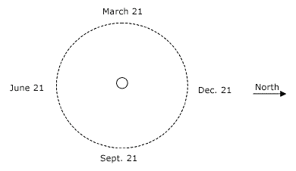

*Setup for Steps 5--9*

**Discussion:**

* Many people think the seasons are caused by variations in our distance from the Sun. While Earth’s orbit is slightly elliptical, it’s very close to circular, and the variation in distance between Earth and Sun is not enough to account for our seasons.
* In the summer, the Northern Hemisphere tilts toward the Sun. It’s warmer because there are more hours of daylight, providing us with more heat energy, and the midday Sun shines more directly head on, increasing the amount of solar energy Earth receives.
* In the winter, when the Northern Hemisphere tilts away from the Sun, the Sun’s rays strike Earth at a lower angle, and the energy from the Sunlight is spread out over a larger area, which reduces its effectiveness at heating the ground. Combined with shorter daylight hours, the temperatures are cooler in winter.
* Because of the tilt, the seasons in the Northern and Southern Hemispheres are opposite. Summer in California is winter in Brazil!
* In winter, Earth is tilted so that Sunlight never reaches the North Pole. It is dark there for 24 hours each day. In summer, the opposite happens, and the North Pole has 24 hours of Sunlight each day.

**The Fabric of Space-Time**

**Passport Question:** What holds planets in orbit around the Sun?

**Passport Answer:** Gravity

**Background Information:**

How do the planets stay in orbit around the Sun? The key is **gravity**. Every object with **mass** (made of matter) has some gravity, and the greater the mass, the greater the gravity. The Sun, has a lot of mass and, therefore, a lot of gravity to pull on the planets with!

This gravity model allows students to experiment with planetary motion.This activity is more of a guided exploration than a lesson. The goal is that students see that the marbles **orbit** around the object with the most **mass**, representing the planets orbiting the Sun. For example, the mass of the sun is about 333,000 times the mass of the Earth.

NOTE: The model is NOT accurate. The marbles eventually fall into the center and the planets don’t! The difference is **friction**—the spandex slows down the marbles, but, in space there is no material to slow the planets down. So, they orbit continuously! While the model isn’t accurate, it’s a great lesson! *Emphasize that friction is the difference.*

**Materials:**

* 7 36” 1.25” PVC pipes
* 14 PVC T-connectors
* 14 34” .75” PVC Electrical Conduit
* 28 .75” to 1.25“ Connector (PVC-1 D2466 IPS 1 x 1/2)
* ~ 72” x 72” piece of Lycra/spandex (Comes in 48” width rolls)
* 20 clamps
* 2 1lb weights
* Marbles
* Other small spheres (ping pong balls, Styrofoam balls, etc.)

|  |  |
| --- | --- |
| **Procedure** | |
| **1** | Lay out the ground rules for this activity: Students must be gentle with the marbles and the model, and they cannot go underneath the model for safety reasons. |
| **2** | Begin with no weight on the model. Roll a few marbles around*. What happens?* |
| **3** | Place one weight in the center of the model. Ask for predictions of what the marbles will do when rolled onto the sheet. *What is the difference?* The marbles should move much more quickly down towards the weight. |
| **4** | Demonstrate how to roll the marbles: they should be rolled gently but with speed toward the edge of the model (it may take some practice to get it down!). |
| **5** | Allow students to explore what they can do with the model. If they seem stuck, prompt them with these ideas:  What if we use spheres of different sizes?  What if we roll marbles in opposite directions?  What if we add a second weight to the model?  What if we roll a small sphere and a big sphere together? |

**Discussion:**

* *If everything with mass has gravity, then wouldn’t the planets pull on the Sun too?* They do! The Sun has a slight “wobble” due to the pull of the eight planets around it. However, since the Sun has so much more mass than the planets, the effect is very small.
* *Why do the planets orbit the Sun instead of the Sun orbiting a planet?* Because of mass and gravity, the object with less mass always orbits the object with more mass.
* *Why do the planets stay in orbit?* Newton’s first law of motion says that an object in motion will stay in motion unless something acts on it. The planets stay in orbit because there is nothing in space to push or pull them, unlike the marbles in our model that are pushed against by friction.
* *If the Sun’s gravity is pulling on the planets, why don’t they fall into the Sun?* In addition to falling toward the Sun, the planets are moving sideways—VERY fast! The force of the Sun’s gravity and the speed of the planets are balanced. Amazingly, the planets are falling towards the Sun but because they are moving so fast that they “overshoot” the Sun and travel in a circular path.

**Exercise like an Astronaut/Exercising in Space**

**Passport Question:** Do objects weigh more on Earth or on the Moon?

**Passport Answer:** Objects weigh more on Earth.

**Background Information:**

Astronauts must exercise twice as hard in space to maintain their strength. Since there is very little gravity on the International Space Station, it requires less strength to operate daily tasks. Because of this difference, when astronauts return to Earth they are much weaker than when they left. So to maintain their strength, astronauts must exercise more frequently and harder than when they were on Earth!

**Materials:**

* Non-breakable containers labelled “3,000 Beans on Earth” and “3,000 Beans on the Moon” (6)
* Tape (to seal containers)
* Dried beans
* Paper (to stuff inside cans so they don’t rattle)
* String

|  |  |
| --- | --- |
| **Procedure** | |
| **Set-up** | Place three cups of beans into Earth container and ½ cup of beans into the Moon can. There are approximately 3,000 beans in 3 cups. Tightly seal each can with tape. Place cans on an outline so students know where to return them. If there is no facilitator, ask another to keep an eye out on the activity. Make back-up cans in case some go missing. |
| **1** | (NO FACILITATOR REQUIRED.) Students lift Earth can with one hand and the Moon can with the other. They compare how different 3,000 beans feel on Earth vs. the Moon. These cans represent the same amount of beans—they just feel different because there is less gravity on the Moon! The amount of mass a planet has effects its gravity. Earth has more mass than the Moon and therefore more gravity. So, a can of 3,000 beans feels heavier on Earth than it does on the Moon. |

**Discussion:**

* *Do you think astronauts must work out more frequently to be prepared for space?*
* *Would you have trouble working out in zero gravity?*
* *What are some creative ways you can think of that would make working out in little gravity a bit easier?*
* *Reduced gravity will lead to a loss of calcium in the bones and weaker muscles. During the space mission,*[*resistive exercises*](https://education.jsc.nasa.gov/explorers/p3_glossary.html)*and good nutrition can help offset some of these changes. Once they return to Earth, astronauts continue to exercise to strengthen their weakened bones and muscles. Scientists keep a careful watch on astronauts before, during, and after flights in space.*

**Working in Space**

**Passport Question:** Circle the reasons that astronauts must wear protective spacesuits and gloves: It is cold in space, there is no oxygen in space, the spacesuit provides protection and a means for survival for the astronaut. **Passport Answer:** All of the above.

**Background Information:**

When in space, astronauts need to be able to leave the space station to complete repairs, make observations, or take samples. But life in outer space can be very dangerous! Astronauts must wear a spacesuit and thick gloves at all times. Without this special equipment their bodies could begin to swell twice their normal size! But the thick safety gloves also make completing simple tasks very difficult. In this activity, students will see just how difficult!

EVA Gloves - Astronauts must be able to work with and pick up objects while wearing spacesuit gloves. EVA gloves are made to protect astronauts from the space environment. They are also made so spacewalkers can move their fingers as easily as possible. The fingers are the part of the body that gets coldest in space. These gloves have heaters in the fingertips. A piece called a bearing connects the glove to the sleeve. The bearing allows the wrist to turn. (From NASA: <https://www.nasa.gov/audience/foreducators/spacesuits/home/clickable_suit_nf.html>)

**Materials:**

* Trifold display board
* NASA gloves
* Legos
* Tub (to place Legos in)
* String
* Tape

|  |  |
| --- | --- |
| **Procedure** | |
| **Set-up** | Place some Legos in a small tub on table. Tape string around the bottom of gloves (multiple rounds around the base of the glove work best to secure them). Tie the other end of the string to the table leg or tape securely to table. Make sure there is just enough slack in the string for students to move glove—but not too much as the activity should still be slightly challenging. |
| **1** | NO FACILITATOR REQUIRED. Students read the board and directions. Students put on gloves and attempt to build a small structure out the Legos. This activity simulates how difficult it can be to move small pieces while wearing thick safety gloves. |

**Discussion:**

* *In space the largest danger is a lack of oxygen or an ebullism (different from embolism). Ebullisms are caused by the formation of bubbles in body fluids due to a reduction in ambient pressure. This is similar to when a diver experiences “the bends.” The pressure in the vacuum of space is so low that the boiling point of your bodily fluids drastically decreases. Your blood won’t boil but you can swell up to twice your natural size.*
* *Also, there is no oxygen in space. So astronauts must always have a large supply of oxygen when venturing out of the space station.*
* *Would you still want to travel in space?*
* *Was it difficult to build a structure using the gloves? Can you imagine how challenging this might be for astronauts?*